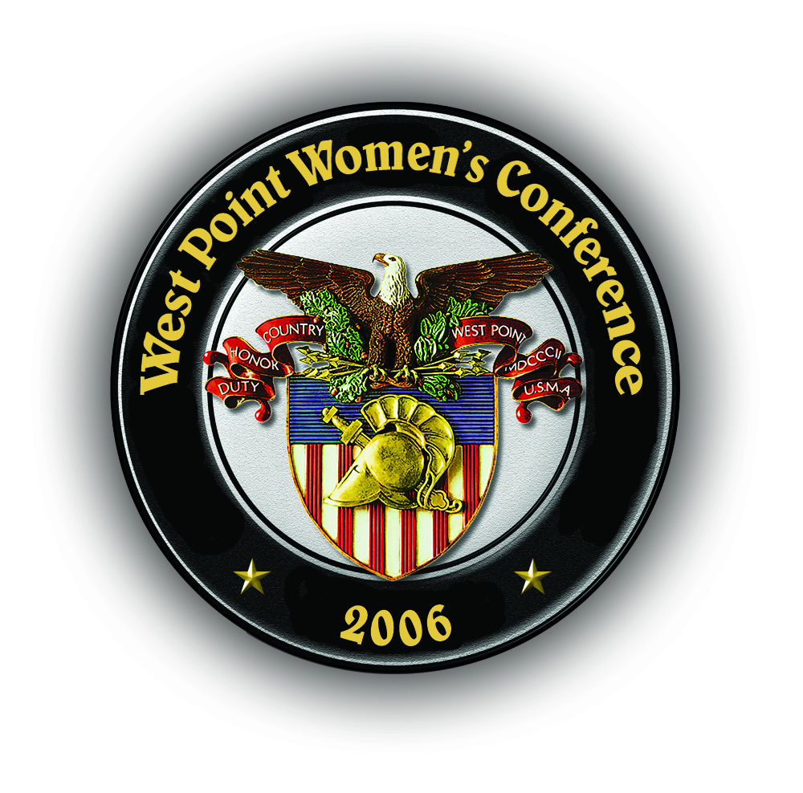

30 Years Celebration – 2006 West Point Women’s Conference

GUEST MEAL TICKETS

Conference attendees may purchase individual guest meal tickets for friends and family to attend the following events. Availability of guest meal tickets is limited, so please place your orders as soon as possible.

Event | Meal Ticket Cost | Number of Tickets | Total  Amount Due
Pre-reception, Parade, Post-reception  Thursday, 27 April 06, 1515-2000 | $20.00
Conference Banquet  Friday, 28 April 06, 1830-2015 | $32.00
Please remit payment in the amount of:

Conference Attendee Name: _________________________________________________

Phone: ______________________________ e-mail: ________________________

Please print and complete this form. Send it with your payment to:

Association of Graduates, USMA
ATTN: Heather Wortinger
698 Mills Road/Herbert Hall
West Point, NY 10996

All checks and money orders should be made payable to: Association of Graduates.

