Capt. Brian S. Freeman
Died on Jan. 20, 2007

Operation Iraqi Freedom

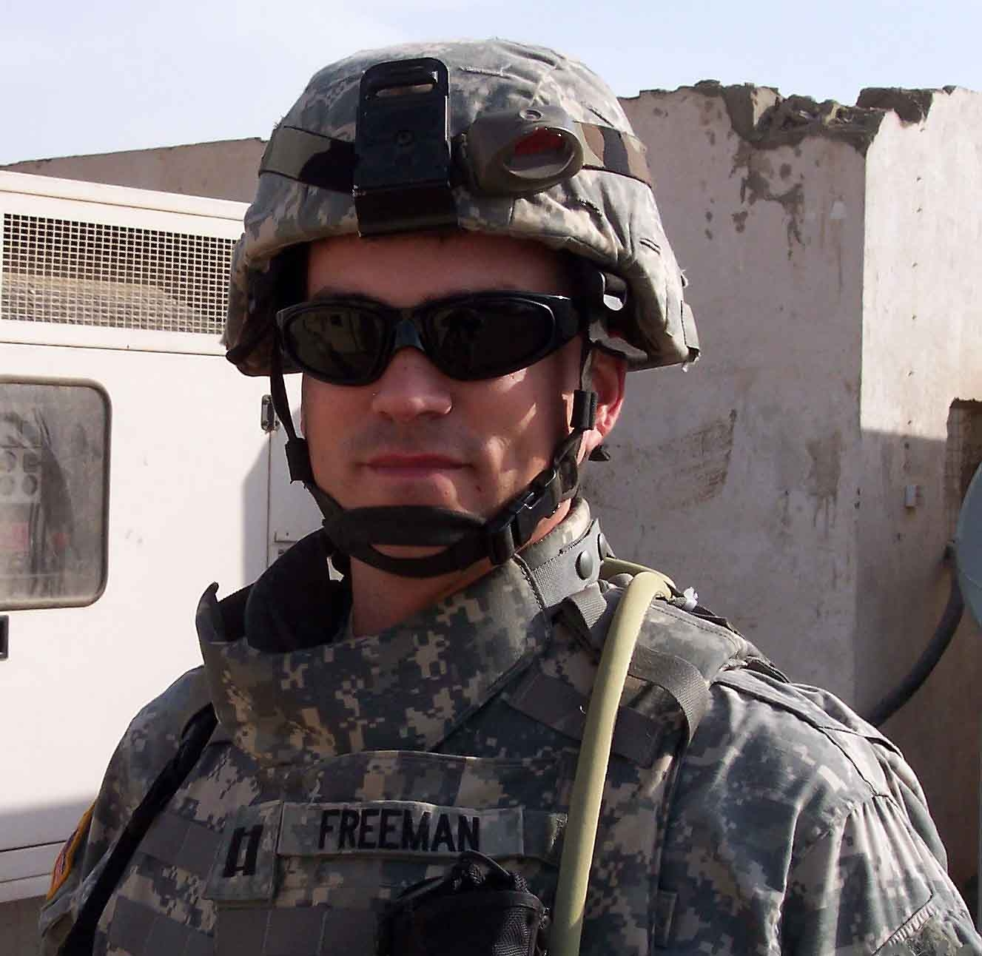
Capt. Brian S. Freeman was born on June 13, 1975, in California. He was a trained civil affairs officer assigned to the 412th Civil Affairs Battalion, Whitehall, Ohio.
He died from wounds sustained when his team encountered both mortar and small arms fire near Karbala, Iraq. Freeman deployed to Iraq in support of the Global War on Terrorism in 2006.
A resident of Temecula, Calif., Freeman began his Army career Aug. 21, 1995, at the U.S. Military Academy at West Point, N.Y. Upon graduation in spring of 1999, he received both his baccalaureate degree in economics and his commission as a second lieutenant.
Freeman joined the active-duty Army for a five-year tour, serving as an armored scout platoon leader assigned to Fort Knox, Ky. In 2002, he was accepted into the U.S. Army World Class Athlete Program, Fort Carson, Colo., with satellite duty at Lake Placid, N.Y., where he trained with other Olympic hopefuls from the U.S. Bobsled and Skeleton Federation.
Freeman began as a brakeman on the America’s Cup Bobsledding Team in 2002, and in the following year, he began sliding skeleton – a single-man, head-first luge. Two of his notable achievements earned him a 3rd in the America’s Cup for bobsledding at Lake Placid, N.Y., Dec. 10, 2002. He later placed 7th in U.S. BSF Lake Placid Skeleton Club Jan. 19, 2003.
In May of 2004, Freeman separated from active duty and joined the Inactive Ready Reserve where he remained until September 2005. Freeman answered his nation’s call to duty and mobilized and deployed with the 412th CA Battalion in April 2006 in support of Operation Iraqi Freedom.
His military education included the Armor Officer Basic Course, Scout Platoon Leader Course, Master Fitness Trainer Course, Air Assault Course, Basic Airborne Course and the Civil Affairs Course.
Freeman’s military awards included two Army Commendation Medals, two Army Achievement Medals, National Defense Service Medal, Global War on Terrorism Service Medal, Armed Forces Reserve Medal with “M” device, Army Service Ribbon, Iraq Campaign Ribbon, Combat Action Badge, Air Assault Badge, Parachutist Badge and the Marksmanship Qualification Badge.
He is survived by his wife, Charlotte, and his two children, Gunnar and Ingrid, all of Temecula, Calif. Freeman is also survived by his father, Randy, and step mother, Kathy, of Bakersfield, Calif., his mother, Kathy Snyder and step father, Al, of Mendon, Utah. Lastly, Freeman is also survived by his grandmother (paternal) Dottie, of Bakersfield, Calif., and his grandparents (maternal), Dwight and Irene Pound, of Solana Beach, Calif.

