

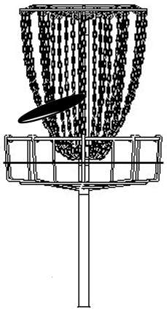

The Rocket City
Chain Gang
Proudly Presents

The Rocket City Blast

PDGA B-Tier
And
Southern Nationals Qualifier

May 28-29 2005
Huntsville, Alabama
Late registration and Check-In:
Friday May 27th 3:00-8:30PM
in the Patriot Suite conference room
of the Holiday Inn Guest hotel
NO SATURDAY REGISTRATION!!!

Limited to 144 golfers

Saturday May 28th
9:15 Player’s Meeting UAH
10:00 Tee Off 1st Round
TBA Tee Off 2nd Round
Sunday May 29th
9:00 Tee Off 3rd Round
TBA Tee Off 4th Round

For Registration Contact Addie Isbell iheartdiscgolf@aol.com
256-489-5128

4 Courses / 4 challenges
Redstone Arsenal
(subject to availability)
UAH
Brahan Spring
Mastin Lake

PRO:
Open - $60
Masters - $50
Women - $50
AM:
Adv - $40
Interm- $30
Recreational - $15

Host Hotel info:
Holiday Inn Space Center
1-800-345-7720 or 256-837-7171
$65/ night Double Non Smoking

