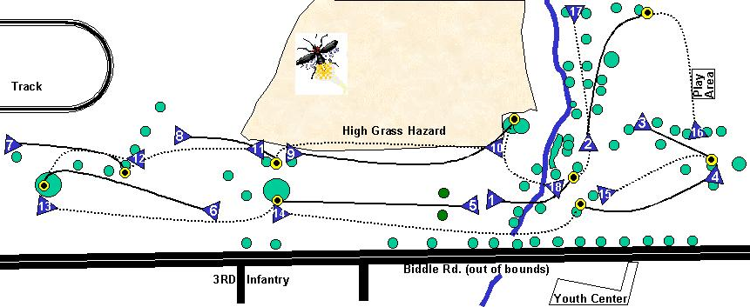

Firefly

Disc Golf Course
3

Name 1 2 3 4 5 6 7 8 9 out 10 11 12 13 14 15 16 17 18 in Total

Firefly
Disc Golf Course

Name 1 2 3 4 5 6 7 8 9 out 10 11 12 13 14 15 16 17 18 in Total

Youth Center

