Jon Scott's Personal Story: College Begins for Some at West Point
Tuesday, July 03, 2007

I won't be on-air at FOX for a few days. My wife and I need time to absorb and then recover from the trauma that's just hit us, something that's irrevocably changed our family and left most of us in tears: this morning, we delivered our oldest son, Josh, to college.
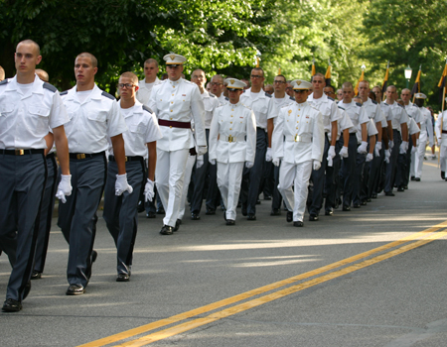
A sample of the new cadet companies on parade, under the leadership of older cadets (in full white uniforms.) Jon Scott

Perhaps you've been down this path before; we haven't, which is part of the reason it hit us so hard. But before you think me a melancholy sap that needs a good dose of "man-up" medicine, let me say that the institution to which we've given up our son isn't an ordinary university. And no, he's not starting out in summer school on this second day of July. Josh is one of 1,311 new cadets hoping to join the class of 2011 at West Point — the United States Military Academy.

I say "hoping" because there are no guarantees. Already these new cadets have taken on difficult challenges, beaten some long odds. Approximately 60,000 high school students "opened files" at West Point, or expressed an interest in attending. 10,800 actually applied. Of those who apply, each must also win the nomination of his or her United States senator or member of Congress. (There are a handful of nominations available through the president, the vice president, or the academy superintendant as well). Of those 10,800 who applied, 2,000 were deemed qualified and offered admission. Josh — and 1,310 others — said yes.

"R-Day" — as this is called in Army jargon for "Reception Day" — is the beginning of Cadet Basic Training, better known as "Beast Barracks." It's virtually certain that before the six weeks of Beast comes to an end, the size of this class will be winnowed down still more. Some will fail the fitness regimen, the running, the pullups, the marching with loaded packs. Some will find Army discipline not to their liking. Some will simply long for the comforts of home — cell phones, e-mail, mom's home cooking — that these new cadets will not enjoy until Labor Day at the earliest. Those who decide to pack it in will likely head for a civilian school someplace where nobody's barking orders and no one's rousing them at 4 a.m. for a 15-mile march in the rain. Those who make it through Beast will shed the "new" in their current title and become full-fledged of the United States Military Academy — albeit as "Plebes" (Freshmen), the lowest of life forms in the cadet pecking order.

No, we're not a military family, until now. My brother served in the infantry in Vietnam; by the time my 18th birthday arrived, the draft was over. The military experience is foreign to me and my wife as well. This desire for West Point is something Josh developed on his own, not because it lay deep in the family genes.

In so many ways, we're lucky. West Point lies on the banks of the Hudson just an hour north of New York City, so we're "locals." We piled Josh, his three siblings, his girlfriend and his parents into the minivan and drove to West Point's appropriately-named "Stony Lonesome" gate at 6:30 this morning. I can only imagine how much more stressful it is to make this trek from Texas or Idaho or North Carolina.

We lined up outside Eisenhower Hall with more than a thousand of America's finest young people, their parents, grandparents and siblings. No one in the crowd had much to say; a combination of tension and exhaustion kept conversations short. It must have been someone's idea of a military joke when, after we snaked through the long line outside the building, the Army finally allowed us inside by welcoming its 18-year-old future leaders through a bank of side doors marked "No Entrance."
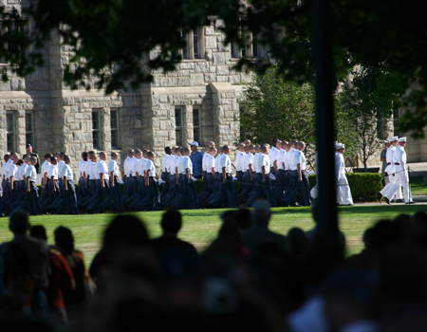
The "new cadets" on their way from barracks to the swearing in ceremony.

We sat enveloped in the cool darkness of one of the largest auditoriums on the East Coast, listening to a Lt. Colonel issue a few quick instructions on the events of the day. West Point then turned over the podium over to an unlikely villainess, a friendly-faced third-year-Cadet named Riley. It was left to her to unleash a thunderbolt from the blue:

"You have 90 seconds to say goodbye."

The dam burst. Eyes ran red with tears. Josh's nine-year-old sister, who adores her biggest brother, began sobbing uncontrollably. There were six of us to hug, to hold, to say a few words, meaning we could grab him for an average 15 seconds a piece. How do you sum up 18 years in 15 seconds? How do you tell your son how much you love him, how proud you are, how excited you are for him, in those precious ticks of the clock? His life raced before my eyes — the nurse holding up a baby eighteen years ago; the shy kid joining a pre-school class; the 12-year-old, stunned by the 9/11 attacks, looking to join Junior ROTC; the football team captain, helping lead his team to a championship season.
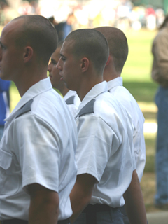
This is about the only shot I got of Josh during the parade; he's the one barely visible

I spoke; my words tumbled out. Too many. He seemed annoyed, or maybe he just wanted out of that emotional moment.

"Let's do this," he said, and with that he picked up his duffel and joined a single-file line that marched out of our arms and into the Army.

We won't see him at all — unless we catch a glimpse at tonight's swearing-in ceremony — and will hear from him very little over the next six weeks. Gradually those restrictions ease as he becomes a cadet and proceeds through the West Point years. Beyond that come the bigger questions: We are, after all, a nation at war. We haven't just given our son to a demanding university, we've given him to the country that he will, tonight, will swear to defend. There are some frightening possibilities awaiting at the end of this four-year tunnel.

Somehow, through the ups and downs of those 18 years, we have rasied a fine son. His future, we leave to God — and the United States Military Academy. Josh, we're bursting with pride. Go Army!

--------------------------------------------------------------------------------
http://www.foxnews.com/story/0,2933,287909,00.html
Jon Scott is anchor of "FOX News Live" weekdays at 12pm ET

