Part III of a Series by Jon Scott: Acceptance Day at West Point

Friday, August 24, 2007
Editor’s Note: In July, FOX News Live anchor Jon Scott dropped off his oldest son, Josh, at West Point, to enter his first year at the military academy. Jon is happy to report that Josh made it through "Beast Barracks." Due to an overwhelming viewer interest, here is the next update — Josh’s acceptance day into West Point.

Has it really been seven weeks?
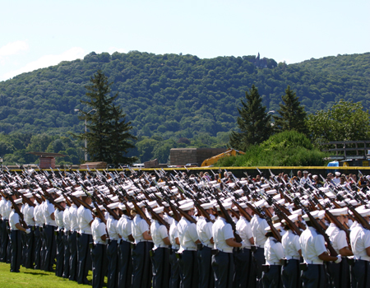
"Plebes" taking up positions in the rear of the cadet companies, already assembled in front of them.

Back on the second day of July, we dropped off our oldest son at West Point — or should I say, West Point snatched him from us. The admission process had been a long, slow march lasting more than a year, full of visits to the academy, applications, essays, letters of recommendation, interviews with congressional staffers, eye exams, medical exams, SAT scores, ACT scores, tests of physical ability and strength and more medical exams. It's a long process, far more involved than an application to any civilian college. The pursuit of his West Point dream seemed to crawl at a snail's pace; but, the day he went in as a “new cadet” was painfully quick.

Yet, that day is more than seven weeks behind us now; Josh and most of the other cadet candidates survived their basic training — better known as “Beast Barracks” — and, this past weekend, the Class of 2011 was accepted into the Corps of Cadets.
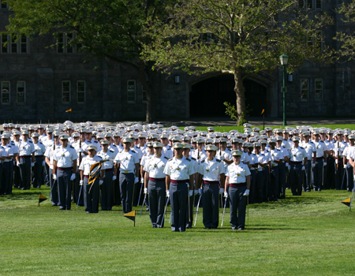
The upper-classmen stand at attention during the A-Day ceremony.
They numbered 1,305 back on July 2 — and, it's my understanding that about 30 dropped out during Beast. To hear their stories, it's easy to understand why. Most were 18-year-olds when they arrived at West Point to be molded into officers — leaders — in the United States Army. It's tough work and it isn't for everyone, even for some of those who might have wanted to attend West Point for years. They'd awaken at 5 a.m., take a few minutes for personal grooming and be outside for P.T. (physical training) by 5:30. The grueling conditioning program was only the start to each day filled with challenges, criticism, setbacks, exhaustion and misery. Somewhere in there they also developed pride, camaraderie, strength, teamwork and confidence. That's what helped them endure and even enjoy what most of the rest of us would probably describe as a miserable experience.

I think of what this class has already accomplished and I am in awe. While their high school classmates enjoyed the languid days of summer, these youngsters were learning the business of defending America. When their friends back home were setting up meetings at the mall, the new cadets were setting up Forward Operating Bases, lying on their bellies for hours without rain gear in a bone-chilling 60 degree downpour. While their “old friends” were visiting old haunts or maybe throwing illicit keg parties in someone's basement, the West Pointers were throwing hand grenades and learning to field-strip their M-16s. Even the relatively few who chose to leave are to be congratulated on having had the abilities, and the guts, to attempt West Point in the first place. These are special people, these cadets.
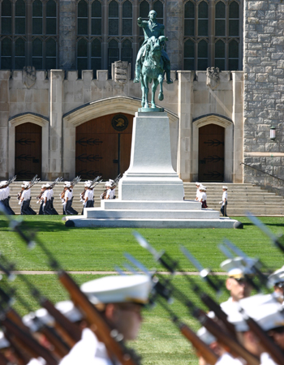
Statues of Generals Washington and MacArthur look over the West Point campus.
Acceptance Day, (A-Day) marks the end of Beast Barracks and — something some cadets said was even tougher — “Reorgy Week” ("Reorgy" with a hard-G sound). Reorganization Week commences as Beast Barracks ends, when the West Point upperclassmen return from their summer assignments all over the world to prepare for the new academic year, and the incoming Plebe class is reorganized and incorporated into new cadet companies.

During Beast, the new cadets outnumber their senior (upper-class) officers three or four-to-one. Once Reorgy Week arrives, that number is reversed — upper-class numbers swell until they outnumber the lowly wannabe Plebes about three to one. It's not just their numbers that brings dread to the hearts of the incoming class — it's their mission: to test the hardiness, the knowledge, the mettle of every single one of these new cadets. Some in the civilian world might call it harassment. It isn't, if I may dare to offer an opinion on something I've never experienced. It is the means these senior officers use to ascertain that those coming up behind them are prepared for the awesome responsibilities of leadership in the most powerful military force the world has ever seen. They experienced it; they learned; and now they want to impart their knowledge, their discipline, to the incoming class. It's what has kept the Long Gray Line just that; an unbroken chain that stretches back to the first cadets at an institution envisioned and then ordered into existence by General-turned-President George Washington.

An example of the tribulations of Reorgy Week: We heard of one unfortunate new cadet who left the relative safety of his barracks room and entered a hallway with his shirt tail untucked. Instantly, he was set upon by a phalanx of upperclassmen determined to correct this egregious breach of Army discipline. Officers must always present themselves in the most favorable light possible; details are important. An officer whose shirt tail escapes his notice might also lose track of the myriad other details required of a leader on the battlefield and, ultimately, that can cost lives. It's the old proverb, "The war was lost for want of a nail." This new cadet was reminded at great length and very loud volume that he will represent West Point and the Army and he will do it to the best of his ability — and he will NOT do it with his shirt tail flapping behind him. Such helpful hounding went on every minute of every day for every new cadet.

Six weeks of Beast and the torment of Reorgy week ended on a glorious A-Day morning. Under the gaze of the statues of Generals Washington and MacArthur and to the beat of the West Point Army Band, the new cadet class emerged from their barracks. Thousands of us watching from the bleachers fell to an awed silence; what had West Point done with our kids? A couple of short months ago, they were just out of high school, conversant in video games, fashion and social networking Web sites. Now they appeared before us as a cohesive military unit, hand-polished brass insignia gleaming on their new white “covers” (hats), ceremonial rifles confidently tucked on their right arms. A thousand suns reflected on shiny silver bayonets as they flawlessly maneuvered their way to the edge of The Plain, the sacred ceremonial ground of West Point upon which only cadets are allowed to stand. New cadets would dare not step on The Plain; but ours were new cadets no longer. A-Day would make them full-fledged members of the Corps.

The upper classes also marched in formation to their appointed spots on The Plain to face the new cadets and the spectators behind them. The Acceptance Day ceremony began, filled with symbolism and dripping with history. Orders shouted and answered; long, powerful commands echoing across the historic field where new cadets have long responded to the call. As a parent, the feelings were overwhelming — knowing that great American leaders with names like Grant, Patton, MacArthur, Eisenhower and Schwarzkopf once stood where our son and his 1,300 classmates were standing this day. Were they also as nervous, as exhausted, as wondering, when they marched on A-Day?

The band struck up the song, "The Rookies." More reverberating commands. Movement from the new cadets. Rifles hoisted high, bayonets gleaming; they strode confidently across The Plain. Forward they marched, two groups melding into one, our "Plebes" taking up positions in the rear of the cadet companies already assembled in front of them — marching to join the men and women who will be their families for the next four years at West Point. Seamlessly, they merged into those companies, then paraded past the superintendent for review. The pageantry of it all is simply breathtaking.

Josh's little sister admires her brother's new white “cover."

A-Day ceremonies are open to the public, and if you get the chance, plan to attend in some future year. Nowhere is the pride and tradition of this great nation on more magnificent display.

After passing for the superintendent’s review, all 4,000 cadets continued their magnificent march across The Plain until they disappeared into the sally ports cut through the gray stone of Eisenhower Hall. The Class of 2011 — class motto, "For Freedom We Fight" — is officially part of the Corps of Cadets. The Long Gray Line is longer still — and stronger than ever.

--------------------------------------------------------------------------------
Jon Scott is anchor of "FOX News Live" weekdays at 12pm ET. Click here to e-mail him! speakout@foxnews.com

http://www.foxnews.com/story/0,2933,294430,00.html

