Welcome to

the

West Point

Parents’

Club

of Greater

Kansas City
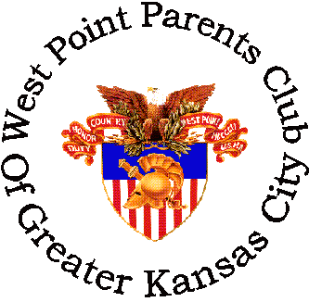

- Who We Are

- What We Are/Do

- When/Where We Meet

- Where We Are

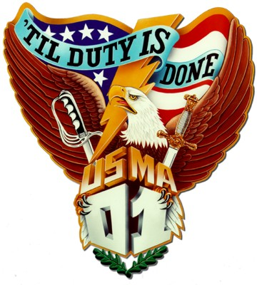
Who We Are

- Parents/Guardians of West Point Cadets
- Parents of recent graduates of West Point
- Club Officers:

- Presidents ~ Jerry & Linda Simonsen 913-492-4573
simonsen@unicom.net
- Vice Presidents ~ Joe & Linda O’Brien 816-836-1248
- Treasurers ~ Virgil and Brenda Bourne 815-459-8647
- Secretaries ~ Ralph & Joni Tiffany 816-364-4837
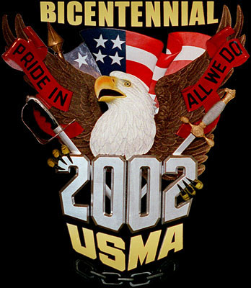
What We Are/Do

- Non-profit organization
- Support all West Point parents and cadets
- Meet five times a year
- Host the All Academies Holiday Military Ball
When/Where We Meet
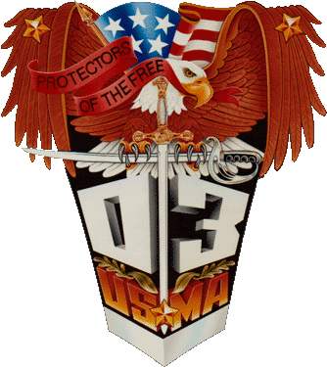

- Meetings are in February, April, June, September and November.
- Meetings are held at various restaurants and members’ homes. Meeting notices are stated in the newsletter on the club’s website http://www.west-point.org/parent/wppc-kansas/
- All Academies Holiday Military Ball is the end of December.
- The Ball is at the Marriott Country Club Plaza Hotel, Kansas City, Missouri.
Area We Cover

 |  | Greater Kansas City Metropolitan Area
As far North as St. Joseph, MO |  |  |  |  | As far South as Wichita, KS |  |  |  | As far East as Springfield, MO |  |  |  | As far West as Ft. Riley, KS

Join the Prospective-net. To subscribe, you will need to go to:
http://www.west-point.org/parent/prospective-net/ and click on the subscribe sign at the lower left.

