For Sale
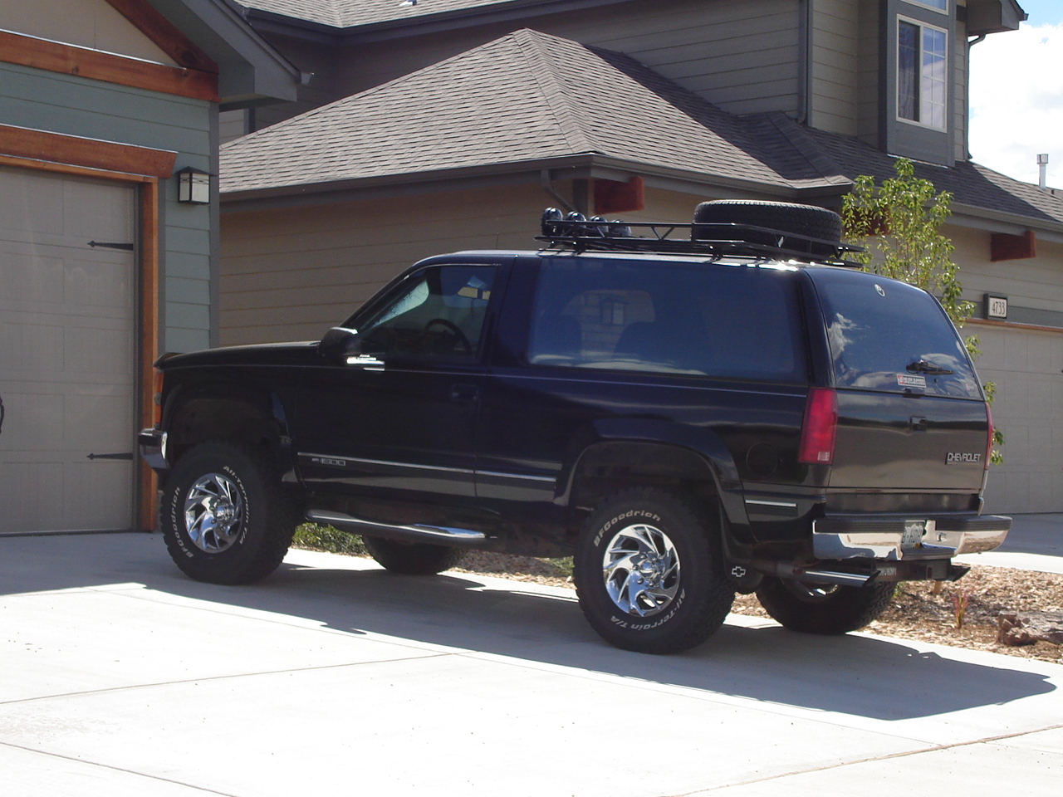
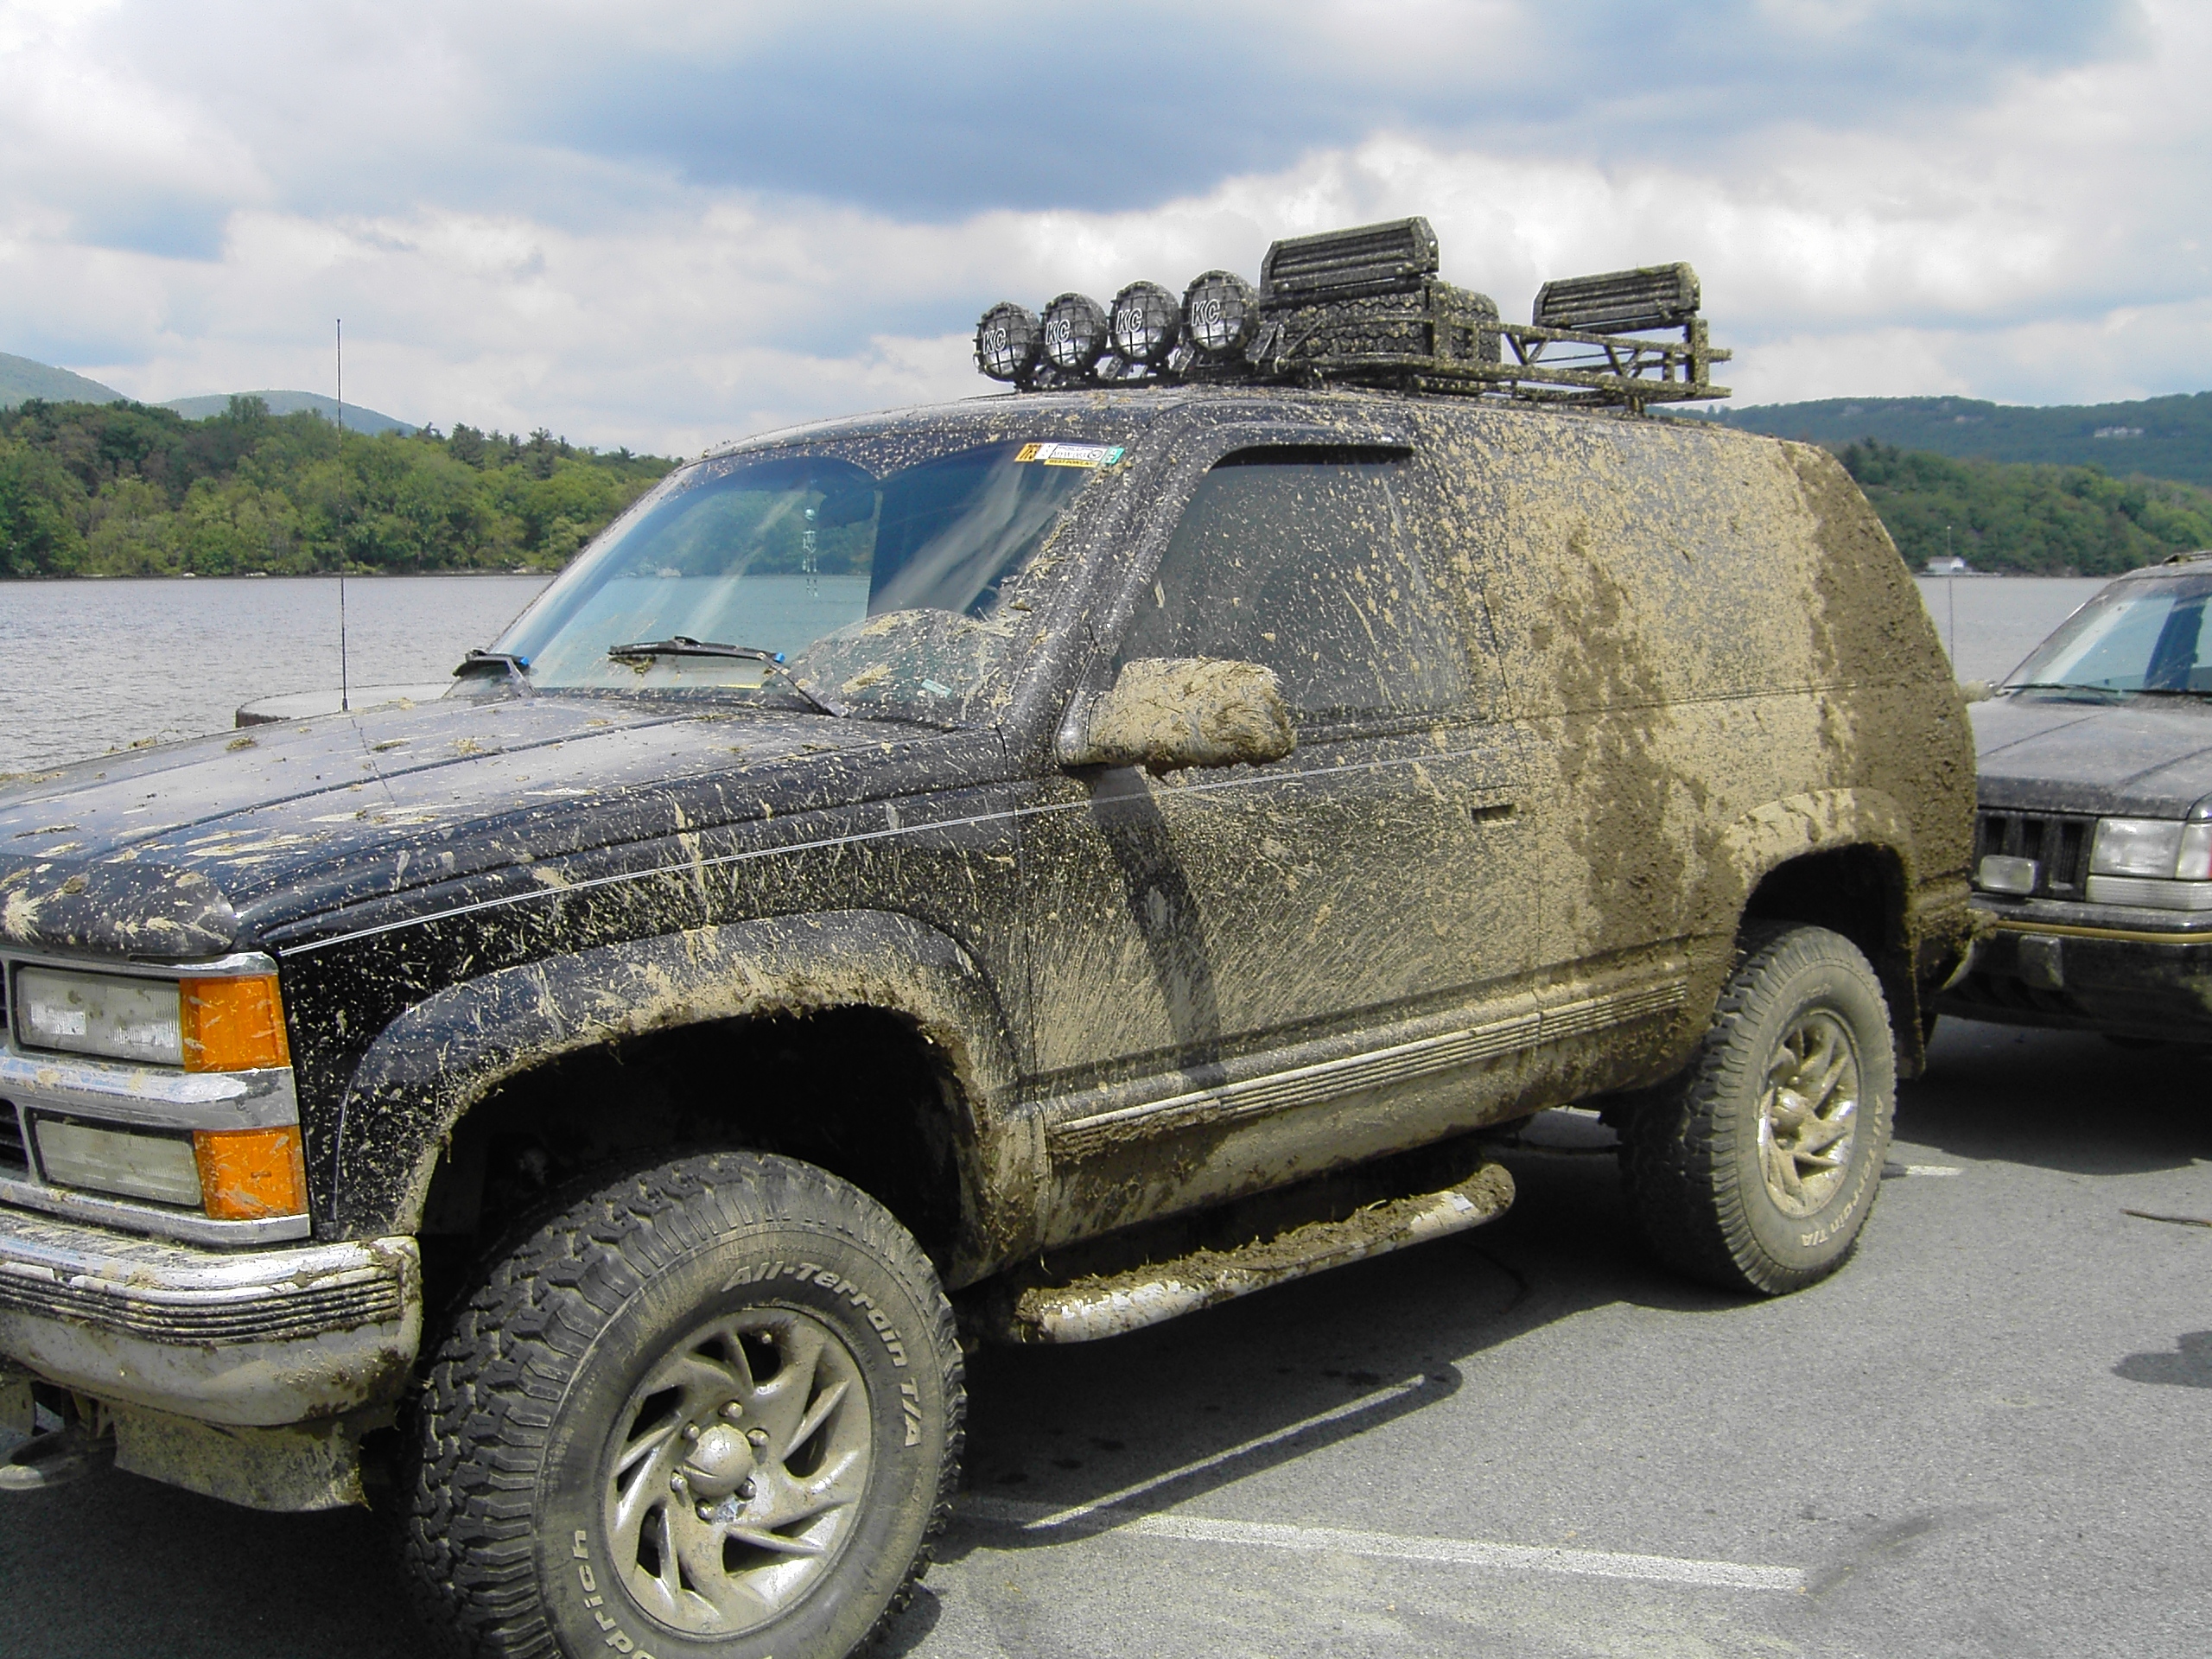

Check out this blazer, it’s a great car for cruising and is the perfect college ride. Dual exhaust sounds like a beast, and it’s great if you want to travel off-road. It’s perfect for camping and weekend trips. It seats 5 including driver. Email me at Robert.meyer@usma.edu if you’re interested and I can give you a tour of it. I need to get a new car because I’m graduating and want a new ride. I had this thing for 5 years and it was my baby, and I’m a perfectionist when it comes to maintaining my car. It’ll treat you right.

Before selling it to you I will get it fully detailed and cleaned, so don’t worry about that. I’m also going to put a new oxygen sensor in it, so that’ll improve the fuel economy a bit.

Specs:
Price: $9,293 OBO
1993 Chevy Full Size Blazer
5.7L Engine with Throttle Body Injection
Automatic Transmission
4wheel drive with transfer case for super low gearing

Modifications/Repairs include:
Towing package | BFGoodrich All Terrain Tires
Chrome 17” wheels | 3” Body Lift
Chrome running boards | Window rain vent visors
Custom dual exhaust with high flow catalytic converter | Throttle body spacer
Replaced all stock speakers with new speakers | Pioneer Deck with two 12” infinity subs and 80Watt Amp
CB Radio unit with antenna and external speaker (PA system) | Wilderness Roof Rack
2 Year old black paint job (used to be white) | 4 KC lights (2 long range, 2 driving) attached to roof rack
New hoses | Spare tire carrier on roof rack
New shocks | Ski/snowboard rack adapter on roof rack

