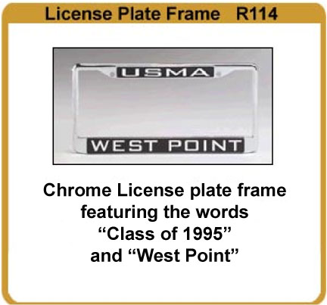
Class of 1995 10th Reunion Merchandise for 2005
See items in color at website www.westpointgiftstore.com
click on Reunions.
Orders must be received NLT August 12, 2005 in order to pick up merchandise at the reunion.
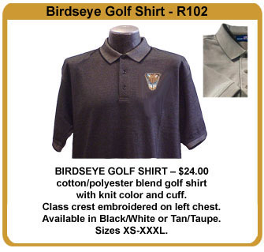
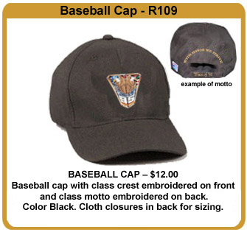

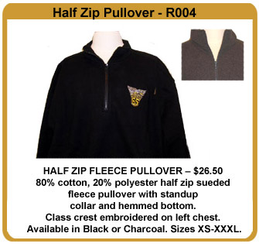
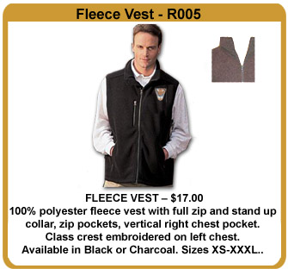
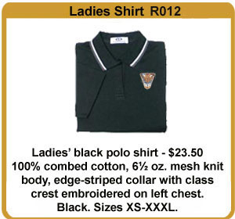
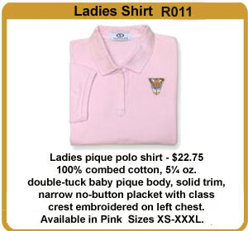
Class of 1995
10th Reunion-Order Blank

To pick up merchandise at the reunion, orders must be received NLT August 12, 2005
Item No. | Quantity | Size | Color  (please circle) | Description | Price/Unit | Total Amount
R109 |  |  | Black | Baseball Cap | 12.95
R102 |  |  | Black / Tan | Birdseye Golf Shirt | 24.00
R004 |  |  | Black / Charcoal | Half Zip Fleece Pullover | 26.50
R005 |  |  | Black / Charcoal | Fleece Vest | 17.00
R011 |  |  | Pink | Ladies Shirt | 22.75
R012 |  |  | Black | Ladies Shirt | 23.50
R114 |  |  | Chrome | License Plate “Class of 95” | 10.00
Please make checks payable to the AOG

Shipping Information
Up to $15.00 add $7.95 $16-$30 add $8.95 $31-$45 add $9.95
$46 to $60 add $10.95 $61-$75 add $11.95 $75 -over add $12.95
 |  |  |  |  | Subtotal
 |  |  |  |  | NY add 7.25% tax
 |  |  |  |  | Shipping
 |  |  |  |  | TOTAL

Name:_________________________________________________________________________

Address: _______________________________________________________________________

City: __________________________________________________________________________

Phone No: Day : (____)________________________ E-mail:_____________________________

Credit Card No:_____________________________________ Expiration Date:________________

Signature:__________________________________________Visa  MasterCard  Amer. Exp.

________Yes. I will be attending the reunion, and will pick up merchandise at registration.
(No shipping charges incurred)

________ No. I do not want to pick up merchandise at registration. Please send.
(See shipping charges above.)

To Order: Or Mail order and payment to:
- Online web store: www.westpointgiftstore.com Association of Graduates / Gift Shop
Then click on Reunions Bldg. 698 Mills Road
- Phone: 800-426-4725 West Point, NY 10996
- Fax 845-446-1279

To contact us: giftshop@aogusma.org

