Own This Special Stivers Print of West Point
No Shortcuts to Greatness
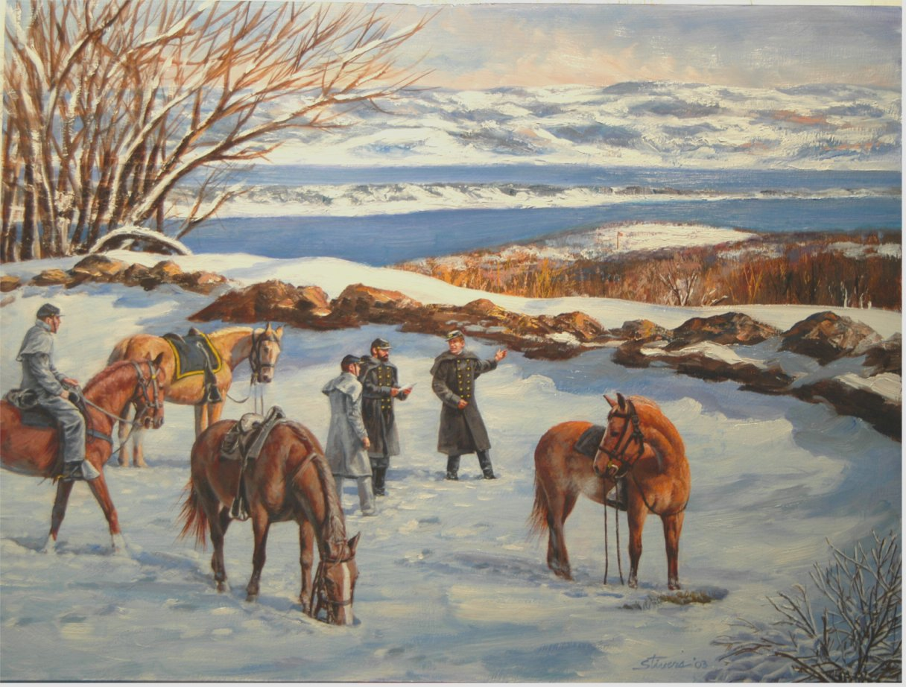
A Description of the Work: No Shortcuts to Greatness honors the extraordinary sacrifices, courage, conviction, and perseverance of all military school graduates. Depicted in the late 1860’s from Redoubt Four’s unique perspective of West Point, this painting recognizes two such remarkable graduates: Captain Charles Parsons (USMA Class, June 1861) and Parson’s student, Cadet Robert Carter (USMA 1870). Throughout his life, Parsons epitomized exemplary service to his country and to humanity. He holds the distinction of being West Point’s only recognized Saint. Similarly, Carter’s actions during cavalry operations in the American West earned him the Medal of Honor. The print image measures 18”x25” unframed.

About the Artist: Don Stivers’ masterful talent of painting military events is well known. Stivers’ originals hang in collections throughout the country and his prints are on display in literally thousands of public and private collections around the world. Stivers’ non-military works have appeared on the covers of Reader’s Digest, Field & Stream, and Time Magazine, as well as the covers of James Herriot’s All Creatures Great and Small series of books. The Cavalry Hall Project edition of No Shortcuts to Greatness is a collaborative effort between Don Stivers and the West Point Society of Philadelphia to benefit West Point and the Society’s Cavalry Hall Project.

How You Can Own One of These Exceptional Winter Prints: Each print of this special edition will be numbered and signed by the artist. Prints will be available until the limited run is sold out. The West Point Society of Philadelphia is using the proceeds from the sale of this spectacular print to directly benefit West Point’s Equestrian Team. With many planned improvements, a critical initial step in the Cavalry Hall Project is to purchase a small covered practice arena. Please hurry and reserve your print today by following the ordering instructions below.

No Shortcuts to Greatness prints are $150*# each with a $20 per order shipping charge. Cadets/military students pay $100.00 per print plus S&H. Please send ____print(s) x $150.00*# each=$______+ $20 S&H=$________. (*$100.00 for cadets/mil students only) Total Amt
Name _______________________________ Phone ___________________ E-mail_______________________

Address ___________________________________City ___________________ State _____ Zip ___________

Make check payable to: “WPSP”. Mail order form and check to: The West Point Society of Philadelphia, The Cavalry Hall Project, ATTN: ADLER: Julian Toneatto ’67, 129 Market Street, Camden, NJ 08102

Pay by credit card#:__Visa __MasterCard _AmEx (Credit Card orders use above address or fax to: 856-757-4050)
(#NOTE-There is a 5% additional charge on all credit card purchases)

Name (as it appears) _____________________________Card # __ __ __ __-__ __ __ __-__ __ __ __-__ __ __ __

Authorized Signature __________________________________ Expires ____/____

For questions regarding this offer: Please e-mail: Or phone:
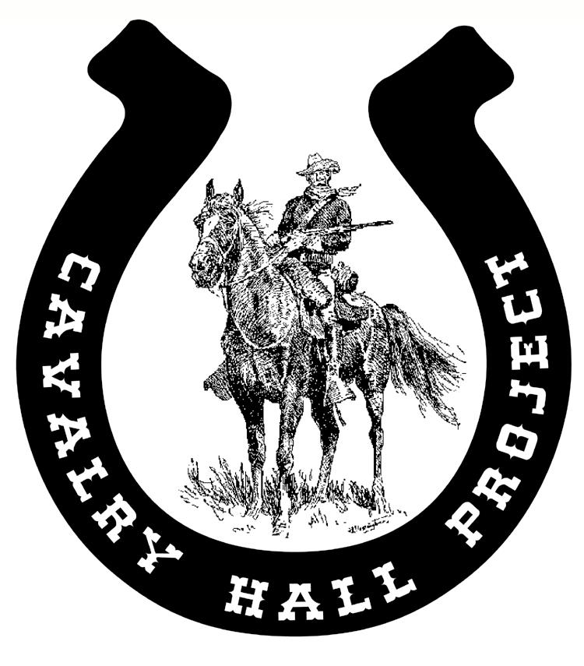
adler@fast.net Julian Toneatto ’67 at 856-757-0070
CavalryHall@aol.com Doug Adams ’80 at 571-332-7248

To Learn More About the Cavalry Hall Project Effort- Visit http://www.aog.usma.edu/soc/philly/
To Learn More About the Artist- Visit http://www.donstivers.com/

