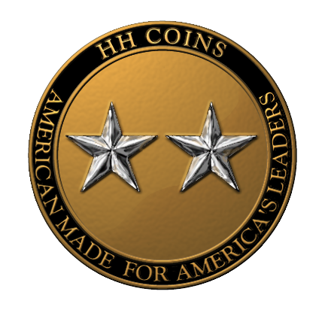
Senator Robert W. Hayes, Jr.
President, USMA Class of 1975
200 Oakland Avenue

P.O. Box 904
Rock Hill, SC 29731

Dear Senator Hayes:

HH Coins has been granted a license by the United States Military Academy and the Collegiate Licensing Company to create USMA Class Coins in bronze and enamel versions. The coins are 1.75 inches in diameter, and weigh approximately 3 ounces. The coins are completely designed and manufactured in the United States.

So far we have minted coins for the three upper classes currently in residence at West Point--2003, 2004 and 2005. We will be working with the Class of 2006 on their coin this Spring, once their Ring and Crest Committee have finalized their crest.

Now HH Coins is turning its attention to graduated USMA Classes. We would like to design and mint a Class Coin for 1975. As Class President, you have the authority to grant us permission to use the class crest for this project.

Included in this packet is our artist’s rendition of both a bronze and enamel 1975 coin. It is the current design being manufactured for the Cadet classes in residence. If you and others on your Class Committee would like to further customize the design, we would be happy to work with you to get the coin exactly as you want it to look. We have several ideas for other design options that we can share with you at your convenience.

The cost for designing and creating the master die for a coin is $1,000.00, payable in advance. The cost includes revisions of the design to your final approval and a review of the master die before manufacture.

Once we are ready to begin minting your class coins, we would ask you or a designated representative to take advance orders and provide a deposit of 50% of the total cost of the order. The costs of the coins are $15.00 for each bronze coin, and $20.00 for each enamel coin. Orders of more than 100 coins of either type receive a 10% discount. The costs of shipping and handling will be added to each individual order and the balance on the order would be payable once we are ready to begin delivery.

Once you have created your own Class of 1975 coin, HH Coins will continue to offer your class the coins as well as other 1975-related memorabilia with your class’ distinctive design. We anticipate having a variety of other items available in the coming months, such as picture frames, humidors, shadow boxes and more.

We look forward to discussing the process of creating our class coin with you. Please contact us at 1-866-H2COINS (1-866-422-6467) or via e-mail at our website www.hhcoins.net.

