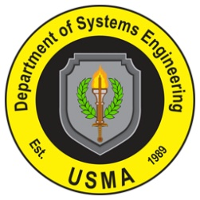
The Advanced Individual Academic Development (AIAD) program provides cadets with an opportunity to observe and implement concepts from their education in systems engineering and engineering management over several weeks during a summer internship. The AIAD program enables cadets to work side by side with leaders in government and industry, both stateside and abroad. It is a critical part of developing our leaders for the challenges they will face in the 21st century. These unique experiences broaden cadets’ perspectives and provide them with practical advanced education related to their responsibilities as future leaders for our military.
Although the benefits to our cadets are clear, experience has proven that the sponsoring organization also gains fresh perspectives and ideas as the interaction prospers. Various government agencies and members of industry consistently report tremendous value added from the employment of cadets as a research program team member or working independently in a technological, challenging environment. The AIAD program can also serve as a conduit into the USMA research network and the possibility for further research work in a year-long capstone project. Cadets have the ability, motivation, discipline, and intellect to make a contribution to any organization. Note some of the feedback from previous sponsors:
- Magnificent job during his summer research effort. The paper submitted is of sufficient quality to be considered for publication in a refereed journal—far exceeding my expectations for this effort. It is important that you know that it was his discipline and intelligence that resulted in such a successful product.
- Possesses a natural insight for policy formulations and issues well beyond his peers. The entire staff was greatly impressed with his diligence, professionalism, and work ethic.
- He completed all tasks, exceeding expectations. Our pleasure and privilege to serve as his sponsor. Look forward to continued future AIAD support.

If your organization is interested in participating in this program in the summer of 2010, please complete the survey at the link below:

http://www.dean.usma.edu/se/selectsurveyasp/TakeSurvey.asp?PageNumber=1&SurveyID=312383MI5941G

