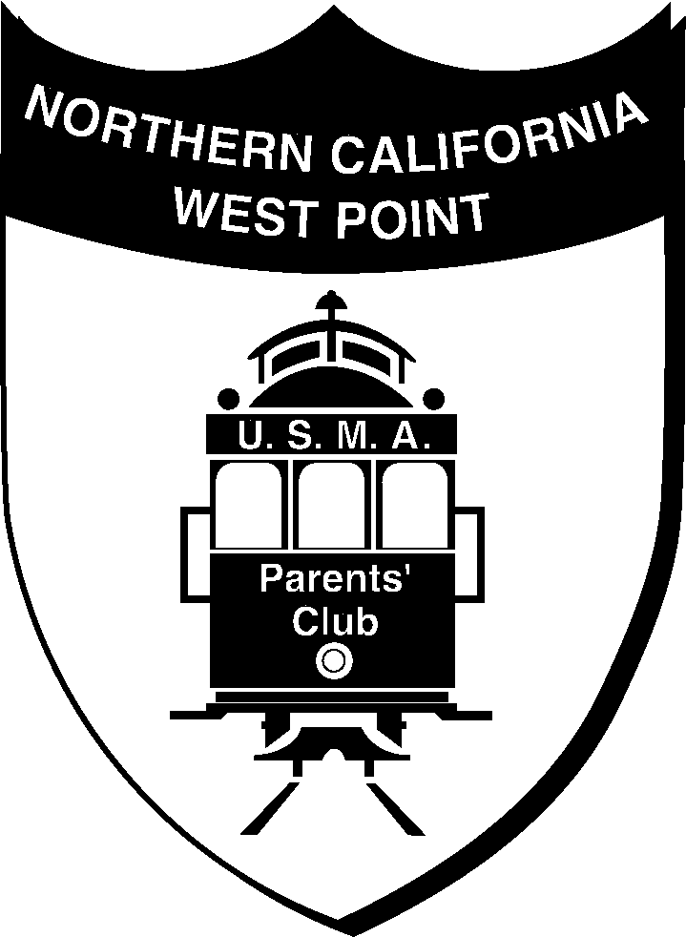

West Point Parents Club of Northern California

MINUTES
2018 GRAD COMMITTEE MEETING
January 14, 2018

1) WELCOME AND INTRODUCTION:
Meeting called to order by Caroline Paniccia. Parents In attendance: Caroline Paniccia (2018), Susan York (2016), Debra and Ron Vega (2018), Linda Updegraff (2018), Lizabeth and J Lipp (2018), Kristina Cooney (2019), Lee Katzman (2018), Cherie and Adam Liebow (2019) Via Phone: Mary Poston (Parent Cadet 2018), Hope Callas (Parent Cadet 2018).

2) MEETING MINUTES:
Committee members and parents discussed budget of approx. $3,000 which will be spent on (18 Cadets) for the following: Archival Memory Book cover shell/Brass Plate Engraved, Filler/Certificate Paper-with border/engraved/Printing, and Flag 3’ x 5’ cotton with Case, and 18 packs of refill pages.

∙ Memory Book (with Brass plate engraved) Archival/Acid Free Book & Archival Page Refills -- Anjana Tikku will provide cost estimate for engraved plate for book cover.
∙ Hat Brass (18) from Cadet Store – Caroline Paniccia
∙ High Quality Blank White Paper Pack & Foiled Certificate Paper Pack – Anjana Tikku
∙ Flag Report by – Debra Vega. The decision was made to order the 3x5 Cotton flag to be flown over the state Capital through Sen. Feinstein’s office. They will also coordinate with Anjana to estimate costs of and then order the Cherry cases and customized name plates. They will make sure flags arrive and are folded properly to fit into the cases for distribution, which is slated to be scheduled for mid or late April.
Options for Club Gifts: need to decide soon is:
1) Flag Case-in cherry color/with engrave plate – Debra Vega & Anjana.
2) Army Officer Tote $35 or smaller Standard Award Tote $20 – Committee decided to gift the smaller tote and forego the candy tin and the Ike dollar.
https://www.marlowwhite.com/standard-award-tote – to be ordered by Caroline Paniccia
3) Eisenhower “Ike” Coin – parents are checking price and if budget allows, Club wishes to possibly gift these as well. The question was asked why an Ike coin is significant…it was found that President Eisenhower, a former WP grad authorized the creation of NASA in 1958 and was therefore chosen for the obverse of the dollar redesign coin, which had been minted with dates 1971-1978, or 1776-1976.
4) 5x7 plaque with Insignia of their Branch and WP insignia was voted down – not in the budget, unless Anjana can find a really great price on something.
5) Candy Tin-with logo on it was voted down, money instead to be reallocated to the Officer case.

∙ Summary: The 2018 Grad Committee decided to gift the Cadets with 2 items: 1) the flag case (cherry) because they match the cherry finish of the Diploma Frame and Commissioning Frame found at the Cadet Store AND the 2) the Standard Award Tote (Marlow White). We need estimates on the cost of these items (plus engraved items) to be turned into Sue York for 18 Cadets ASAP. IF the budget allows, we will entertain getting the Ike Dollar and the wall plaque.

∙ Budget Report Manager – Susan York (2016), thank you for offering your expertise with this task!

∙ Letters of Recognition report by – Cherie Liebow
All information needed from Cadets was collected and by Linda Updegraff and given to Cherie Liebow.
Cherie Liebow will send out Letters to Dignitaries this week and may include former Grads, Businesses, and possibly the “Supe”?

∙ Pages for Memory Book – Caroline Paniccia and Linda Updegraff.
Linda Updegraff will start building files for each Cadet, to start putting pages in. Caroline Paniccia and Linda Updegraff will start collecting and producing laser printed pages. They will meet and discuss final page requirements, content, type of paper, and layout.
We need Anjana Tikku to give us a quote on 8.5”x11” Foiled Certificate packages, as well as price quotes for Archival 8.5”x11” empty refill pages that will match the Album. So that we can get started building the content.
∙ Details for inside book will be further discussed as a committee– such as photos, Granite rock, etc.

∙ Hotel – Hotel Doubletree Inn in Nanuet, contact Naji Saliba at naji.saliba2@hilton.com
∙ Luncheon & Commissioning Appts at Thayer Organizer – Hope Callas
Hope Callas is working with Thayer and coordinating with AOG to get site up for parents to order and pay their tickets online. Contract is signed and deposit confirmed. More details to come.
Bus Coordinator – Anjana Tikku and Hope Callas
Anjana Tikku is finding out bus services and charges, more details to come. (Note: Bus will pick up from Doubletree Inn in early AM and drop off at WP for Grad Ceremony. The return trip will take place about 7:00PM or so, after all Commissionings at Thayer take place…if your Cadet is joining you on the return trip, they will need their own Full Fare ticket!)

3) EVENTS:
February: 100/500th Parent Luncheon/Dinner TBA– will be sometime in February located in the East Bay. Coordinated by 2018/2019 Class Reps.
Mid/Late April: Firstie Book & Gift Pickup Event – Caroline Paniccia and Committee will coordinate and have a Firstie Book/Gift Day (Luncheon?) for April TBA. Memory Books and flag/cases (should they be back by then) will be handed out to parents, additional refill page protectors papers will be given to parents to customize. Also handed out will be all gifts that the club purchased, and go over any final questions and concerns before the big day!
May: Grad Week Preparation – Hope Callas will coordinate with AOG & Thayer to summarize of attendance for luncheon and table coordination, as well as assign Commissioning appointments for those Cadets deciding to Commission at the Thayer following the luncheon. *Notify Hope Callas at wh.callas@att.net of your Cadet’s intent to commission at the Thayer Hotel as soon as he/she has made this decision final, Please and Thank You!
June: Almost-a Plebe Luncheon – Possible Brass Door Restaurant-San Ramon

4) OTHER BUSINESS UPDATES:
∙ Website and Constant Contact – Caroline Paniccia is working on Website revising and brining up to date. Constant Contact, had to completely start over, with revising and inputting. Successfully launched on Wednesday Jan 10, 2018.

∙ Cadet excel sheet with details of Cadets – Linda Updegraff updated and contacted parents to update the excel sheet. Was able to get most info, but some still missing info. Will be contacting those parents to get up to date missing information.

∙ Howitzer Ad: Linda Updegraff is designing and getting all info on deadline for the ad placement. We will need an Official West Point Portrait of your cadet, Plebe or Firstie photo will be cropped, she is checking on size and format. MANDATORY: All 2018 Parents MUST submit this photo as soon as Linda lets us know the size requirement in order for this design to be placed in the Howitzer, otherwise, no photos will be used at all!!

∙ More help may be needed as we get closer to the graduation date, if you can help in the months coming up, please contact Caroline Paniccia.

5) NEXT MEETING:
The next 2018 Grad Committee Meeting will be held a phone conference and then we will meet at the 100th/500th Luncheon for the next meeting! Save the date when you see it!

6) FUTURE AGENDA ITEMS: Memory Book/supplies status, Page Content, budget, gift ordering status, custom engraving for book plate & flag case plates. Dates for February, March, April meetings, status of totes, candy tin, plaque and Howitzer Ad… etc.

7) ADJOURNMENT:
The meeting adjourned at 6:30pm.

Minutes reviewed by Caroline Paniccia & Submitted by: Linda Updegraff

Attached to this document will be the Meeting Agenda. Please inquire about any further links or attachments from the meeting.

GO ARMY!!

