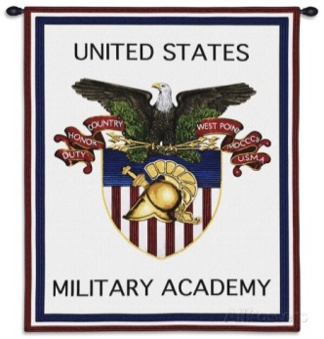
The West Point Parents’ Club of Illinois
Class of 2023 Letter Writing Event

Members & their families gather to write letters to our IL Plebes to give them encouragement (spiced with a little humor) to finish Beast strong! New cadet parents have the opportunity to share their initial impressions of West Point with other parents who truly understand.

Date: Saturday, July 27, 2019
Time: 11:30am – 1:30pm
Location: 22 East Chicago Avenue, Naperville, IL
(SE corner of Washington Street & Chicago Avenue)
Unmarked office located in strip mall with Five Guys & Chipotle; look for WPPC sign to identify the door which is just east of Forever Yogurt

Parking: Minimal space in the strip mall; more
parking available at the garage directly across the street or around the North Central College campus just east on Chicago Avenue

We’ll provide the letter writing supplies and light refreshments. Please bring five (5) first-class postage stamps per family along with any cartoons, jokes, & news/sports articles you can tuck in a letter that might make our new cadets smile.

RSVP to Trisha Bottarini trishbott@yahoo.com by 7/20/2019

