West Point Parents' Club of Massachusetts



Handbook for Firstie Parents
Class of 2001
Class of 2001
"Till Duty Is Done"


Well, here we are, parents of Firsties! Next year at this time we will be the proud parents of Second Lieutenants. Wasn’t it only yesterday that we wished our starting Plebes a good start? Those same children, who worked so hard to get into West Point, are now working just as hard to get out. They have learned so much, grown in a million ways, and matured into wonderful young men and women.
The West Point Parents' Club of Massachusetts hopes that this handbook will serve as a guide throughout your cadet’s last year at West Point. Most parents have more questions during this year than during the second and third years put together. The WPPC-MASS newsletter, forum and website will keep you posted on upcoming events and schedule changes.
It's never too soon to start planning for graduation. Cadets often have too many other things to think about and it is left up to us to make the arrangements. This handbook highlights what you should be aware of as the year progresses. You will receive graduation information from West Point in late February. We are including a copy of last year's information so that you know what to expect. Have your cadet obtain a schedule of graduation week activities (available in early spring), so that your family can plan ahead. The Academy sends these to parents in early April. As graduation time draws near, anxiety and emotion can run high. Plan ahead so that you can sit back and enjoy this experience. When your cadet steps out of ranks to receive the final salute from the Corps at the graduation parade, give yourself a pat on the back for also making it through four years at the Academy.

RING WEEKEND
The first major event of Firstie year is Ring Weekend - generally held the last weekend in August. Some cadets may want to invite their parents for this; others may prefer to have just their boy or girlfriends. The festivities begin on Friday night in the open air concert area of Trophy Point with a private ceremony for Firsties only; this is when they receive their coveted rings. After the ceremony, the Firsties go to “the area,” and other locations, where the Plebes will admire their new rings and greet them with the “Ring Poop”. Dropping to one knee, the Plebes will chant:

“Oh my God, sir/madam!  What a beautiful ring!  What a crass mass of brass and glass!  What a bold mold of rolled gold!  See how it sparkles and shines!  It must have cost you a fortune!  May I touch it please, sir/madam” | 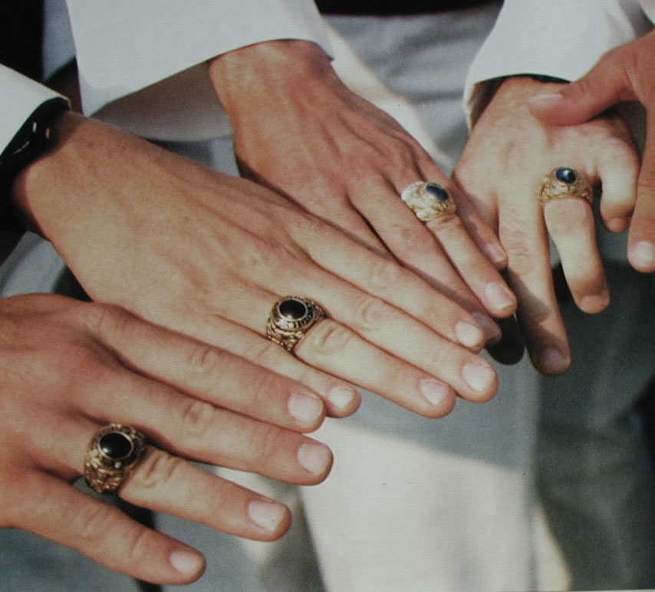
After that, the Firsties are free to spend the weekend with you and their dates.
On Saturday, there are various open houses, followed by a formal dinner and ball. Women should wear long gowns or cocktail dresses, for men, dark business suits are in order. Cadets will be attired in their India whites. Firsties have the option of having their pictures taken inside a 9-foot, 500 lb. replica of their class ring. The lines for this are extremely long, so bring your camera to the ball at Eisenhower Hall and take your own pictures.

HISTORY OF THE WEST POINT RING
The U.S. Military Academy was the first school in this country to use rings as a class symbol, the tradition beginning with the Class of 1835. With the exception of the Class of 1836, which chose not to have class rings, and the Class of 1879, which chose cuff links, each class has worn rings to symbolize their pride in West Point and each other.
Until 1969, the style of the rings was selected informally, but that year an organized meeting was held for deciding upon the design. Thus began the Ring and Crest Committee, the members of which are chosen by each class during Cadet Basic Training.
After considering crest designs submitted by members of their class, the committee formally announces its choice during Plebe-Parent Weekend. Each class ring must have incorporated within its design: an eagle, an American flag, an officer’s saber, a cadet saber, the class motto and year, and “USMA."
Since the Class of 1917, rings have borne a class crest on one side and the crest of the Academy on the other. Although the design is uniform for any given class, the content of gold and type of stone is the choice of each individual cadet. Legend has it that one cadet chose a small stone from “the area” to represent the many hours that he had spent there walking off demerits.
A cadet who resigns or is separated from the Academy prior to graduation forfeits the right to wear the class ring. It is customary until graduation for the ring to be worn so that the class crest is most easily seen by the wearer; after graduation, the ring is reversed so that the Academy crest is the one nearer the heart.
Each class since 1835 has chosen its own motto, traditionally in Latin on the earlier rings, although one was in French and one in Scottish. Now the Motto is in English and usually rhymes with the year.

ARMY UNIFORMS - BLUES AND GREENS
In September, Firsties have an opportunity to order their Army uniforms. The blue uniform is the “Dress Mess” for formal occasions. The green uniform is considered the “Class A.” If the cadet elects to choose one of the tailors, such as Haas or Jacob and Sons, the cost of both uniforms will total approximately $900, but the work is excellent and usually includes lifetime tailoring. The blue and green uniforms are also available through the Post Exchange for about $500. The lower cost, we are told, reflects garments of somewhat lesser workmanship with no fitting included; the cost of alterations would be the responsibility of the cadet.

BRANCH SELECTION
During the first three years at the Academy, each cadet is given information from branch representatives and faculty members about the merits of each branch and particular talents required. By the end of October, Firsties must select a branch. The Branch Notification Ceremony presently takes place the third week of January. Post selection is made by the Firstie in February and is announced by the Army in April.

MAKING RESERVATIONS FOR GRADUATION WEEK
By now, most of you should have your hotel or motel reservations made for Graduation Week. If not, we suggest that you start checking with your favorite hotel/motel immediately to find what its graduation stay requirements are. Some hotels and motels will take reservations several years in advance, some will not take any reservations for the current year until 8:00 AM on January 1. Most motels will have a 3 or 4 day minimum stay, so check with your favorites now and see what regulations they have. It is never too early to make your reservations. At the last minute, there is usually no problem finding accommodations in areas such as Suffern, provided you don’t mind a 25 minute commute. Just pack everything that you will need for each day.
On Friday of Graduation Week, after the Graduation Parade, there will be ample time to get back to your motel, shower, and change into formal clothes for the banquet at 7:30 PM.
A Holiday Inn Express hotel in Ft. Montgomery is scheduled to open October 2000. Reservations can be made either online or by calling Holiday Inn.

100th NIGHT
This event is celebrated by cadets in late February/early March and commemorates the mere 100 days remaining until graduation. It permits the Firsties to reflect upon their four years at the Academy.
The celebration begins on Friday night with the 100th Night Show at Ike Hall. The show - written, directed, acted, and produced by Firsties-- is a tradition dating back to the late 19th century. It's evolved from a series of short skits to a full-length musical comedy, and depicts their years at the Academy. The Friday night show is open only to Firsties and their guests. Like Ring Weekend, 100th Night is a cadet event, although many parents attend.
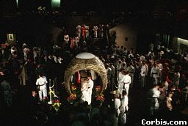
Saturday is unscheduled during the day. In the evening, a formal banquet is held in Washington Hall for Firsties and their guests. This is followed by a formal ball; cadets wear their full-dress uniforms. Dark suits for men and dressy attire for women are appropriate. While the ball is in progress, the 100th Night Show is presented once again and is open to the public and to underclass cadets.

If you attend 100th Night, don’t expect your cadet to stay with you the entire weekend. Cadets may want to be with their fellow cadets. It is slowly sinking into their heads and hearts that their Academy experience will soon come to an end.

GRAD WEEK INFORMATION
Early in the spring of the Firstie year, your cadet will have the opportunity to order graduation invitations and/or announcements. (Be careful: some people interpret these announcements as invitations.) At the same time, they order “Thank You” notes and cards labeled “2LT" (similar to a business card). You may want to assist your cadet with the names and addresses of some family members who need to be included. Also, the Academy will mail you a Graduation Week Schedule. You will see that there are activities during the entire week before Graduation. Some parents attend for the whole week, and some come for just Friday and Saturday or a long weekend.
Graduation Week events and attractions include academic open houses, Glee Club / USMA Band / organ concert, awards ceremonies, USMA bookstore, Cadet Parachute Team demo, Cadet Drill Team, museum, Tower Suite restoration, and much more. Cadet award ceremonies will be held Tuesday PM (athletics), Thursday PM (department - academics), and Friday AM (stars, wreaths, etc.). Consult the attached Class of 2000 “Graduation Week Schedule” for a typical schedule of events. Regardless of how much time you choose to spend there, you will want to arrive no later than noon on Friday for the big parade. There is also an awards parade on Thursday prior to the Friday graduation parade around 11 AM which includes a terrific demonstration by the Black Knights, the Army Parachuting Team.
During Grad Week be sure to visit of the Firstie Club. Prices are reasonable and the Club is open to the families of graduating cadets for lunch and dinner.

And stop by the Highland Falls liquor store to purchase a bottle of the Class of 2001 Wine (approximately $15.00).
Your flower needs can be met by the flower store in Highland Falls.

ESSENTIAL TIPS

- A medium sized cooler filled with “cold” bottled water, orange juice or any soft drink to have available during the ceremony.
- A tote bag filled with snacks, ex: bagels, muffins or doughnuts. Be sure to bring napkins and paper cups.
- Bring a towel to wipe down the bleachers if it has rained the night before.
- It is VERY IMPORTANT to be at the stadium at least two hours before the cadets’ march-on.
- Bring extra rolls of film, including batteries. The stadium sells film but not batteries.
- Organization is the key to a successful graduation experience. Try to have your plans worked out ahead of time and you’ll enjoy graduation.
- It cannot be over stressed how important it is to be early for all the events and activities during graduation week.

SUPERINTENDENT’S RECEPTION
Each Regiment has an opportunity to attend the Supe’s reception - usually 1st and 2nd Regiments on Wednesday afternoon and 3rd and 4th Regiment on Thursday afternoon. Held at Quarters 100, in the garden area, the reception is an opportunity for cadets and parents to meet and mingle. Dress is business casual (dresses/suits/jackets/ties) and although tents are put up for shade, this can be a very hot and sticky event - or cold and windy.

RELIGIOUS CEREMONIES
On Thursday evening, usually 7:30 PM, the Most Holy Trinity Church, Cadet Chapel and Jewish Chapel all hold Baccalaureate Services. You must arrive early. There is no view from the seats in the back. If you have attended services with your cadet at West Point before or simply want to give thanks in this manner, services at the chapels are available at this time. Those who have attended in the past tell us that these are very special and very moving ceremonies and are not to be missed.

GRADUATION PARADE
This is the final parade held specifically for this class of cadets. They bid farewell to the corps with a final salute and are on their way. Held on the Friday afternoon before graduation, usually at 2 PM, on the Plain. If you intend on arriving that day, plan to be there before noon. Do not try to drive on Post; go to Buffalo Soldier Field to park and take a shuttle; one runs every 20 minutes, but the lines will be long. Plan to arrive early for all activities because seats fill quickly. Although your cadet will probably be able to get you approximately 3 tickets in the reviewing stands for the parade, you will find that ‘squatters’ often infiltrate the bleachers and fill the seats; the stands will be very crowded. For additional family members, there is ample standing room around the sides of the field. Feel free to bring folding chairs and blankets. Bring your camera.
If the weather should be hot - water is a must! There are no fountains on the Plain and you will be in direct sunlight for three hours! Small plastic bottles work great.
After the parade, the Firsties join their parents and guests so it is important that you set up a meeting area with your cadet before the parade.
By 2:45 PM, the parade will be history and you will have, hopefully, found your cadet. There are some nice shade trees behind the reviewing stands; these provide a cool place to chat and take additional pictures. Keep in mind that you will probably be hot and tired and will need to get back to your room to change for the banquet. Remember that although this is a very special day for you, the regular community will be getting out of work and there will be traffic as they work their way home. Leave extra time for driving back and forth.


GRADUATION BANQUET
This is a formal affair with long or cocktail dresses for the women and dark business suits for the men. Usually each cadet is allowed to purchase 3 guest tickets for the banquet. Some Firsties will only need 1 or 2 tickets and your cadet can ask around and pick up an additional ticket or two from others. The Firstie can also purchase tickets for the overflow banquet at the Officers’ Club. These are on a first come, first serve basis as there are only 400 seats there. The Academy in the past has arranged for family members who do not have tickets to the banquet to attend a satellite banquet at the West Point Club. The tickets will be sold only to cadets and are limited to two (2) tickets per cadet. The meal is the same as served in the Mess Hall and there is an audio hook-up so the speeches can be heard. The Academy will make announcements (via e-mail) to let the Firsties know what arrangements can be made. Make sure your Firstie is aware of what you need.
After the banquet there is a formal reception and dance at Eisenhower Hall, usually from 9:00 PM to 1:00 AM. This is a great time to meet with old friends and share memories.
Our club takes a photograph of Massachusetts graduating Firsties on the night of the banquet. This picture is then published in the Howitzer. Please be sure to watch for announcements from the Club on the time and place of the picture-taking and be sure to bring your Cadet.

GRADUATION CEREMONY
Graduation takes place at Michie Stadium and is scheduled for 10 AM. Under normal circumstances Graduation is open to the public and the gates to Michie Stadium open at 7:00 AM and it is not unusual for lines to begin at 8:30 AM. Additionally, the ceremony is usually available for viewing in Christ Arena, Holleder Center, which may be an option for the less stalwart if the weather takes a turn for the worst. The doors open at 8:30 AM. Dress comfortably for the weather; in the past, the weather has been hot and humid. The Visitor's Center is a good alternative for those not wishing to deal with the weather or the hike to Michie. It is open, air-conditioned and the ceremony is televised on a big screen television.
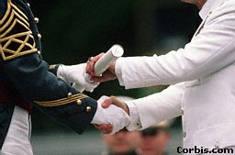
Make sure to ask your cadet where he or she will be seated. Cadets are usually grouped according to companies, and each is assigned to a specific seat of a certain row. If you have a good pair of binoculars, you might even be able to find your cadet on the field. For some reason, with 1,000 identical full-dress uniforms, they all tend to look rather similar. All cadet’s names are announced individually when receiving their diploma.
After the customary opening remarks and presentations, the featured speaker will give the graduation address. The ceremony is not elaborate, but is impressive and solemn in its tone and setting. The members of the graduating class are about to assume the positions of responsibility for which they have worked so long and hard to achieve; their cadet careers are fast coming to an end as they await the presentation of their diplomas. Usually several dozen distinguished cadets receive their diplomas first; then the rest come forward in a specified order. After all of the diplomas are presented, the Superintendent gives the Commissioning Oath to the graduates. The First Captain then announces, “Class Dismissed,” and the graduates toss their white caps high into the air.
While the diplomas are being presented, many children will gather on the field eagerly awaiting the traditional “Hat Toss" in which there is a scramble for a white treasure. All cadets have their names inside their hats and some will even write a special note to lucky, anonymous recipient. If you are taking along children to the graduation it may be wise not to get them too excited about “getting a hat” as there are age and size range restrictions: teenagers are too old and toddlers are too small. All children must be as tall as the wooden cadet positioned at the location where they are told to meet. Listen to the announcements made prior to the ceremony for instructions.
NOTE: If the President of the United States happens to be the speaker, be aware that security will be very tight. You will have to walk through a metal detector, have your handbag (and any other bag) searched, and have your camera examined. Because of all of this extra processing time just to get inside the stadium, you may want to arrive much earlier than 8:30 AM. The entire area will be crawling with Secret Service men and women and there will be sharp-shooters in high places. Some of the reserved seat assignments will be changed for “security reasons.” Even after you are actually inside the stadium, if you stray outside of the security perimeter (perhaps looking for a restroom), you will have to pass inspection a second time.
Final Note: Many parents have reported that because this can be a very hectic and emotional day it is suggested that you order a Graduation Video when they are offered so that you will have a lasting memory of this day.

FOR THE PHYSICALLY CHALLENGED
Your cadet must make special arrangements for any handicapped members of the family, and this must be done well ahead of time with their TAC. Special handicap parking passes (in a color different from the regular graduation pass) will be issued although the Military Police will honor the handicap plate issued by your state for special parking. This may change from year to year so be sure that your cadet checks on this. The shuttle service for handicapped persons can be a very slow process. Make sure that your cadet has checked out arrangements for the handicapped and remember that a lot of the Academy is not handicap accessible. It would be good planning to have an able-bodied family member responsible for helping the infirm members.

AFTER GRADUATION
By tradition, new Second Lieutenants present a silver dollar to the first enlisted person (from post, in this case) to salute him or her after graduation. The silver dollar is generally uncirculated and of the current year although it has been known to be a tradition that a silver dollar be handed down through the Corps. This is best purchased by YOU at HOME, where it will cost only $8, or $11 including box and tax. In the area of the Academy, the same silver dollar can cost up to $25 because of the demand.
WPPC-MASS gave a silver dollar and an American flag—flown over the Capitol—to club members' sons and daughters graduating in the Class of 2000.
For the convenience of members, WPPC-MASS orders silver dollars in the spring. Purchase orders can be entered at the March meeting of the club, or by mail as announced in the club newsletter. Dollars purchased this way will be delivered at the next meeting or by mail.
If you plan to attend the Thayer luncheon after graduation, you must have advance reservations - book far in advance. The Thayer Hotel will send you a mailing about this.

TENT RENTAL AND CATERERS

It is possible to have your family celebration on the grounds of West Point but it is not a simple process and should be begun by February of the graduation year.

The initial contact is the Director of the Fields found in the Dept of Physical Ed. The form he will send to you is the USMA Reg 210-6. Your cadet will need a sponsor to send this form through the system for approval. This person could be his original sponsor, a professor, or TAC officer, for example.

Popular sites are South Dock and Buffalo Soldier Field. By 3 PM on Saturday afternoon the only people at Buffalo Soldier are the few families tenting so it is nothing like a football Saturday or other college graduations you may have attended where families linger for the day. Tent companies can supply all you need including tables, chairs, linens, grills, china and flatware, or paper products.

TENT COMPANIES
Montgomery Hudson Valley Tent: 845-788-3175, 800-255-2698
Newburgh Classic Tent: 845-564-5858
Highland Champion: 845-691-8236
Orange County Rental: 845-342-5611 (Used by Club families on recommendation of caterer and they were happy with the service.)

CATERERS
Nicoles: Rte 9W. Highland Falls. Cold buffet was excellent. They deliver
Pamela's Traveling Feast. Rte 9W. Newburgh. Sit down dinner was excellent.
Grand Union
Cadet Restaurant
CB Driscoll: Montgomery 845-457-1300

There were many restaurants and stores in the area that had signs in their windows about catering during grad week. If you want to leave your food arrangements until then or if have last minute needs, the local establishments are handy.

BAR PINNING CEREMONY
Sometimes this happens, sometimes not; particularly not if the President speaks, because of security. If the cadets, no, Second Lieutenants, are allowed to have this, they will change into their new uniforms (Greens) in the company barracks. The cadets choose the place and persons (parents, fiancée, etc.) for the pinning of their first bars, their “butter bars.” In the event that this ceremony would be held at someplace like Ft. Putnam, it might be a good idea to have some walking shoes along. Other popular sites include Trophy Point, the Chapels, the Plain and the statues on the Plain.

MOVING OUT OF THE BARRACKS
The barracks must be emptied by 5 PM on Graduation Day. Cadets usually clean ahead of time, wash the floor and walls so that the rooms will pass inspection by the TAC. To avoid the mad dash that afternoon, it is possible for most of this to be accomplished prior to Saturday. Once again, if the President is the speaker and stays on post for a luncheon, security remains tight, so you will not be able to get your vehicle anywhere near the barracks area to load the gear.

SATURDAY NIGHT
This is a nice time to take your new officer out to eat. After an exhausting couple of days, you might not want to begin your ride home until the following day. If you will be driving home Saturday night, you will have to check out of your motel room prior to the graduation ceremony. Be aware that many of the graduates may want to stay for the weekend, primarily due to all of the weddings (of their fellow cadets) that take place in the post chapels during the remainder of the weekend. Some families get together and have group parties at various hotels, function halls, etc., talk to your cadet about what plans they may have following the graduation ceremony.

GRADUATION GIFTS

WPPC-MASS presents a silver dollar and an American flag is flown over the White House on 100th night to the membership graduates. Cash is a practical gift, if only because graduates will have little space for storage of graduation presents. Graduates will have many opportunities to wear civilian clothing; they'll appreciate cash or gift certificates to help with clothing purchases. Sporting goods may also be nice gift idea.
Laptop computers and cell phones make a great grad gifts, too. They'll help your new 2LT stay in touch. Gift sabers are also appreciated. They can be ordered early in the year from either the C store (845-938-2121) or the AOG Gift Shop. We're told that the C store offers sabers at lower price.
Your cadet will receive a diploma and Commissioning Certificate. If you buy frames for these from the C store or via mail order solicitations you will receive, be careful to order matching frames. There are several vendors and styles available.

WHERE DO THEY GO FROM HERE

Within 30 to 60 days after graduation, new Second Lieutenants begin the Officer Basic Training Course for their assigned branch. There are 16 different branches; the length of OBC can vary from several months to a year or more.
Usually, graduates are granted leave for the period between graduation and the beginning of OBC. During this time, enjoy the company of your West Point graduate!

CONGRATULATIONS!

Special thanks to the West Point Parents' Club of Pennsylvania
for the outline of this document.

Note:

The following section is a sample copy of the Class of 2000 information booklet that was mailed to
Firstie Parents from West Point.



You will receive your copy of this year’s information directly from West Point later in the year.

