Trail Design and Construction Project
for

Buffalo Mountain Natural Area Preserve

1. SCOPE OF WORK

1.1 GENERAL PROJECT DESCRIPTION: The Contractor shall construct a hiking trail to the summit of Buffalo Mountain Area Natural Preserve (BMNAP) in Floyd County, Virginia (Figure 1). At 1140-acres, BMNAP is home to at least 13 rare plant species, 3 rare animal species, and 5 globally-rare plant communities. BMNAP is owned by the Commonwealth of Virginia and is managed by the Department of Conservation and Recreation’s Division of Natural Heritage (DCR-DNH).

This trail project includes the construction of new foot trail (~4750 feet), the conversion of portions of the existing forest road into foot trail (~700 feet), and the deconstruction and rehabilitation of the remainder of the existing forest road (~2500 feet), rendering it impassable to off-road vehicles. Contractors submitting bids must have hiking trail design and construction experience. Work sections are identified in Figure 2 and are described in further detail in the narrative below.

1.2 CURRENT CONDITIONS: The current hiking “trail” that climbs 550 feet to the summit of Buffalo Mountain is an old fire tower forest road. Steep grades (15-30%), insufficient outslope, excessive tread-width, failing and/or non-existent drainage structures, and severe erosion characterizes the current condition of this trail. All-terrain vehicles (ATVs) are an on-going threat to resources at BMNAP and have exacerbated these poor trail conditions. In conjunction with increased law enforcement and patrols at BMNAP, this trail project will address ATV trespass and devise strategies to reduce their ability to access BMNAP.

  - ACTIONS NEEDED: This project includes the following: construction of a pedestrian hiking trail extending from the parking lot to the summit of BMNAP and deconstruction of all portions of existing forest roadbed not used as part of the trail. Specifications and Definitions found the Virginia Department of Forestry’s Best Management Practices for Water Quality (2002) and the U.S. Forest Service’s Trail Construction and Maintenance Notebook (2004) will be the standard technical references used on this project.

Section A
This section will be newly-constructed foot trail extending from the parking area and tying into the existing forest road ~700 feet below the summit (start of Section B). Section A is ~4750 feet in length. The trail will be constructed within a 100-foot lateral distance to either side of the path marked by DCR-DNH staff. Contractor experience, discretion and natural features will dictate the exact location within this 200-foot wide corridor. The exception to this 200-foot wide corridor will be any sensitive areas identified and marked by DCR-DNH staff. The finished trail tread width will be 24” - 36” wide, and will be constructed to shed water through water diversion features. These water diversion features include: reverse grade dips, water bars, ditching, and turnouts. Reverse grade dips are the preferred feature.

Section B
This section consists of the last ~700 feet of trail below the summit. This section lies within the existing forest road bed. The trail tread will be reconstructed within the existing road corridor, using machinery and hand tools to reduce the outslope berm and restore an appropriate outslope. Disturbed soil adjacent to the trail tread will be stabilized using annual rye grass and organic litter. The finished trail tread width will be 36” - 48” wide, and will be constructed to shed water through water diversion features. These water diversion features include: reverse grade dips, water bars, ditching, and turnouts. Reverse grade dips are the preferred feature.

Section C
This section consists of the deconstruction and stabilization of all sections of the existing unused forest road (the old fire tower road) not used as part of the trail. The approximate length of Section C is 2750 feet. The roadbed will be deconstructed and stabilized using heavy equipment and hand tools. The finished product will be constructed to shed water through sheet flow and other water diversion features (reverse grade dips, ditching, turnouts, etc). Soil and rock material from the roadsides will be relocated to the roadbed to facilitate out-sloping, eliminate erosion and “naturalize” the roadbed. Natural materials will be placed in a manner to redirect human traffic to the new trail and exclude the passage of off road vehicles whenever possible. Disturbed soil will be stabilized using annual rye and organic litter.

The three large rocks above the public parking area will be removed from the fire road to allow machinery to access the entire length of fire road. Following completion of the project, these rocks will be used at the parking area as part of an obstruction to off-road vehicles. This off-road vehicle obstruction will be constructed of stone, be a minimum of 24 inches high and extend across the upper portion of the parking lot and slope for approximately 100 feet. Contractor and DCR-DNH staff will determine exact placement of obstruction at time of construction. The existing gate at the parking area will be removed. The existing kiosk will be relocated and installed near the parking area at a specific location to be determined by DCR-DNH at the time of relocation.

  - TRAIL SPECIFICATIONS:
Tread Width: 24 – 48 inches
Clearing Width: 6 feet
Vertical Clearing Limit: 8 feet

- Use of On-site Materials: On-site materials such as rocks, trees, soils, etc within the general trail corridor can be used to construct trail features/structures when it has been determined that their use will not adversely impact the natural resources on the site based upon a field review between the Commonwealth and Contractor.

- Use of Quarry Materials: Contractor shall attempt to use native materials to the extent possible. The determination to allow quarry materials such as rock, rip-rap, or crusher run, will be based upon a field review between the Commonwealth and Contractor.

- Trail Tread: Native mineral soil and/or quarried stone with a cross slope of 3-15% for sheet drainage. All organic materials shall be removed leaving an even, compacted, uniform surface free of indentations. Organic materials shall be scattered off of the trail on the downhill side. Organic materials are not to be used for cut and fill.

- Tree Cutting Diameter Limits: No tree shall be removed that is >10 feet from the edge of the trail. When removing trees that are growing in the downslope berm along the old trail / forest road, Contractor shall attempt to leave all trees > 6 inches diameter at breast height. Exceptions will be made based on a field review between the Commonwealth and Contractor.

- Brush Removal: Trees and brush cut from the corridor shall be removed to a distance of at least 15 feet from the centerline on the downhill side of the trail. Cut trees and brush shall be cut up so it lays near the ground, not exceeding three feet in height.

  - OTHER ITEMS:

  - COMPLETION DATE: Work shall be completed no later than October 1, 2007.

Figure 1.
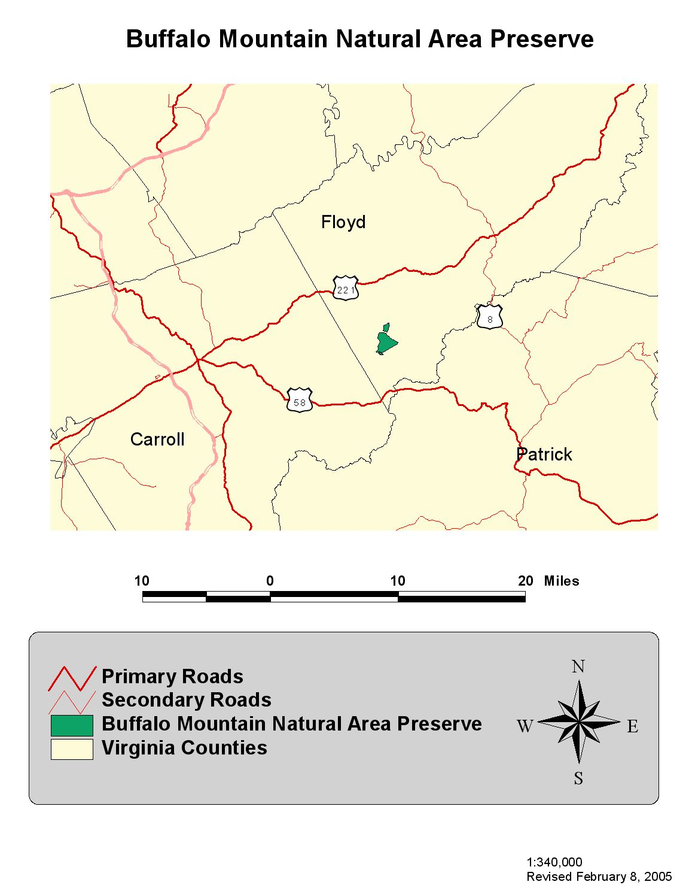
Figure 2.
