Class of 1980 – 30th Reunion
Suggested Reunion Order Items Available from your WPAOG Gift Shop

CB Polo - R837 Men & R401 Women | Crest Polo – R051 | Half Zip Pullover - R004
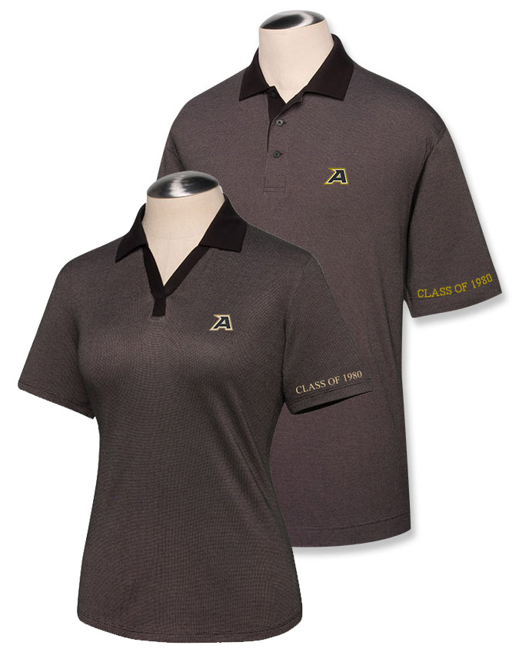  Cutter & Buck Polo - $42.00  Classic styling enhanced with rich silky texture and a quick-dry finish. 60% Pima cotton, 40% micro polyester. ‘Class of 1980’ embroidered on left sleeve.  R837 Men’s Sizes S-XXL  R401 Women’s Sizes S-XXL | 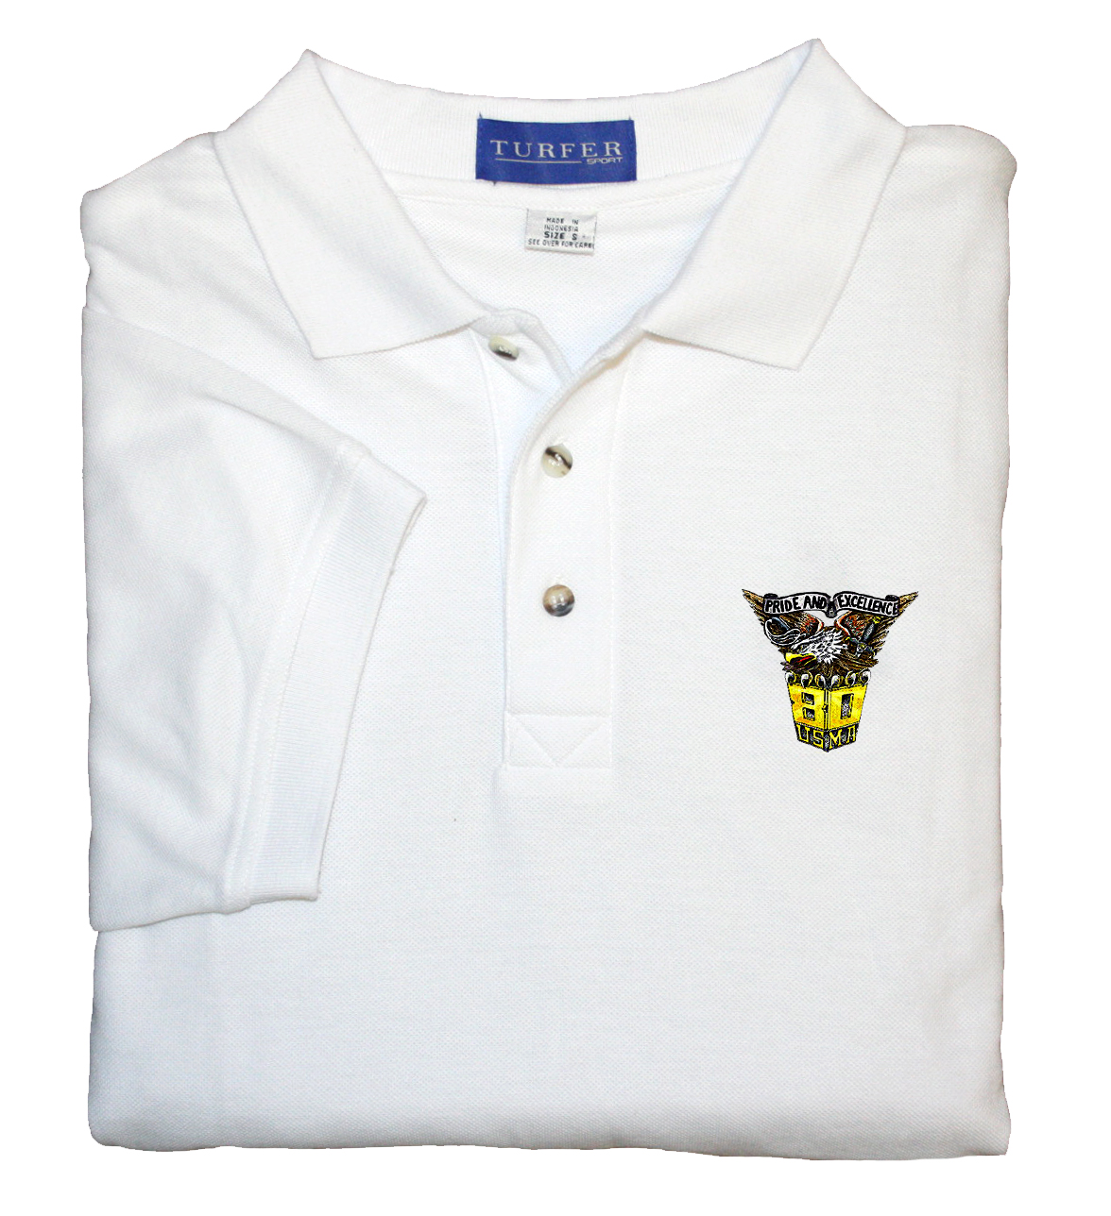  Crest Polo Shirt - $33.00  Polyester cotton combination for long lasting durability. Double needle detail. Available in White.  Men’s Sizes S-XXXL  Women’s Sizes S-XXXL | 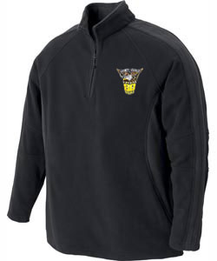  Half Zip Fleece Pullover - $45.00  75% Recycled polyester/25% Spun polyester anti-pill fleece. Zipper placket with fine contrast piping detail. Available in Black with gray contrast collar, shoulder and sleeves.  Men’s Sizes S-XXXL
Luxe Touch Jacket – G496 | Microfiber Jacket – R101 | R121 Fleece Blanket
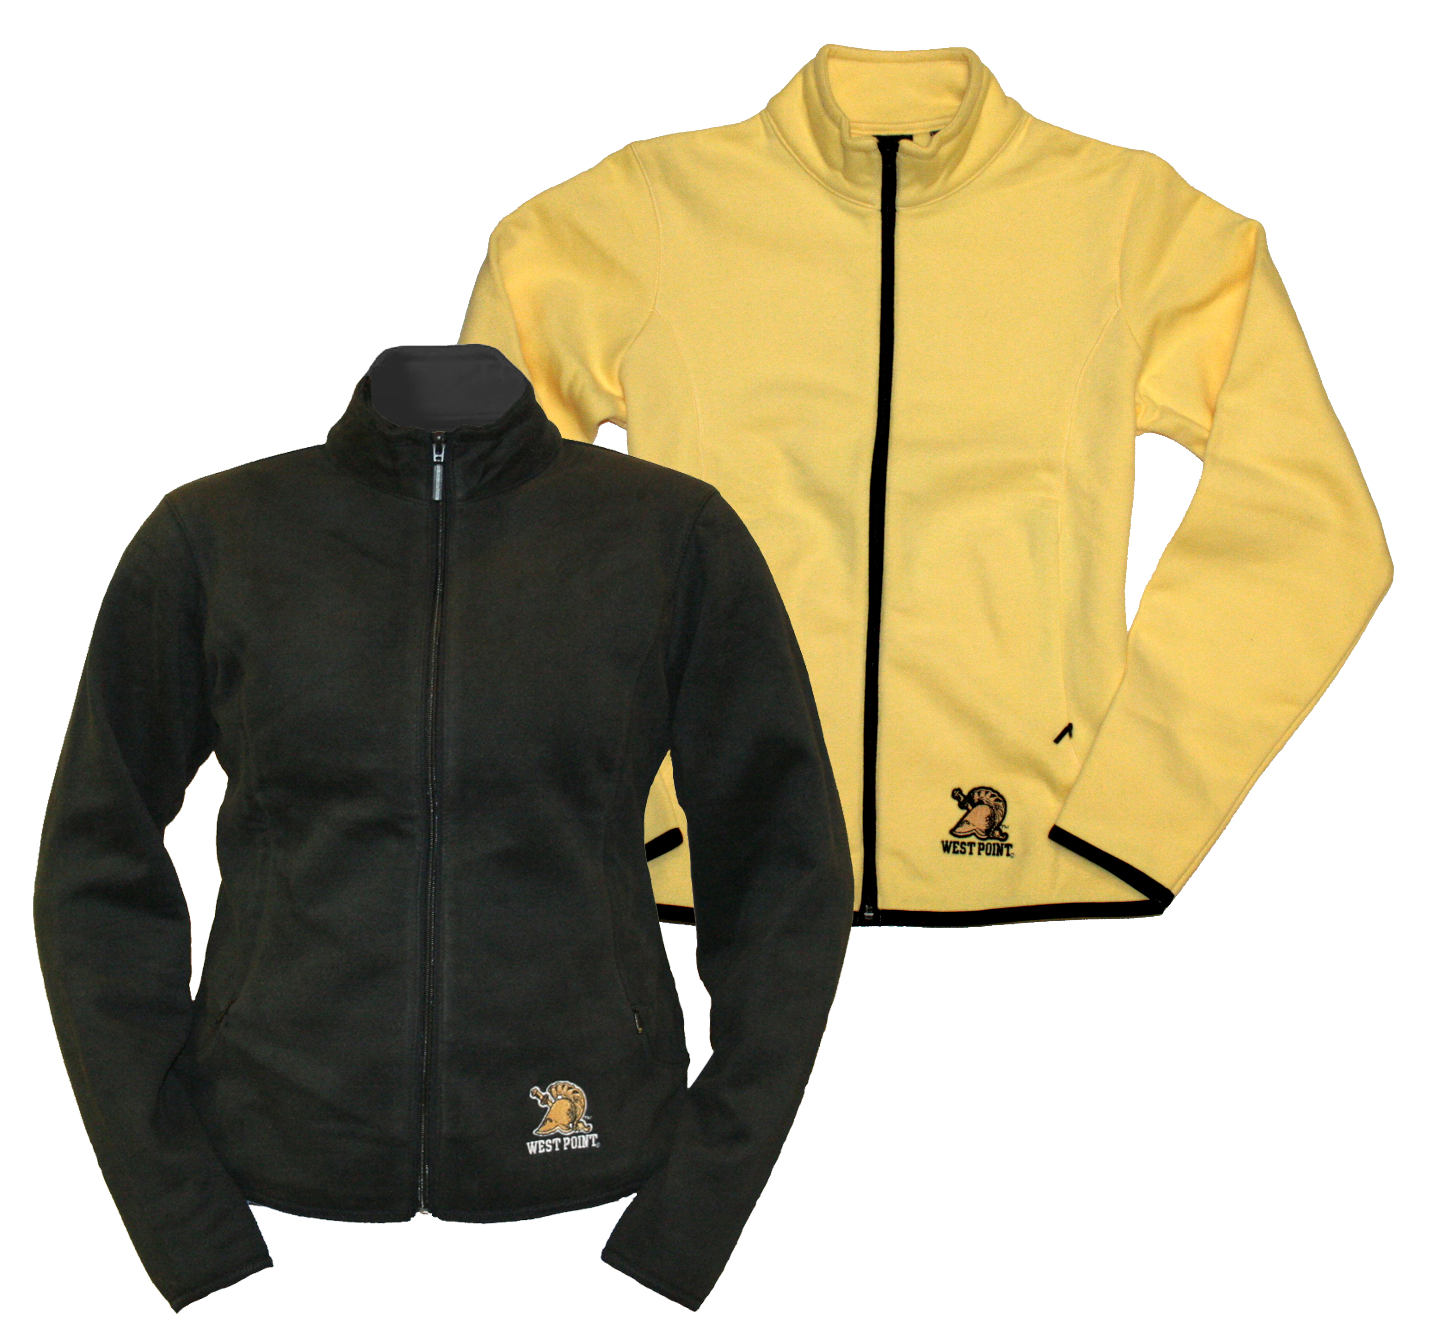  Luxe Touch Full Zip Jacket --$52.00  Luxe full zip jacket with on seam zipper pockets and sueded fabric finish. Fully embroidered Athena Helmet under left pocket. 80% Cotton/ 20% Polyester. Available in Black or Yellow.  Women’s Sizes S-XXL | 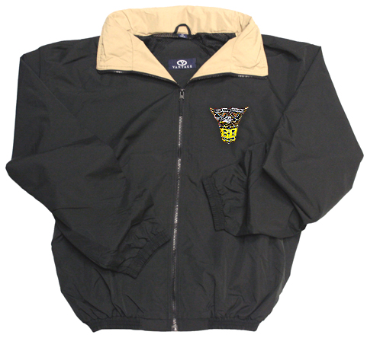  Microfiber Jacket - $57.00  100% polyester sueded microfiber body with water repellent finish, stand up collar with contrasting lining, full zip front with zip out hood, mesh lining. Class crest embroidered on left chest. Available in Black with Khaki neck lining.  Men’s Sizes S-XXXL | 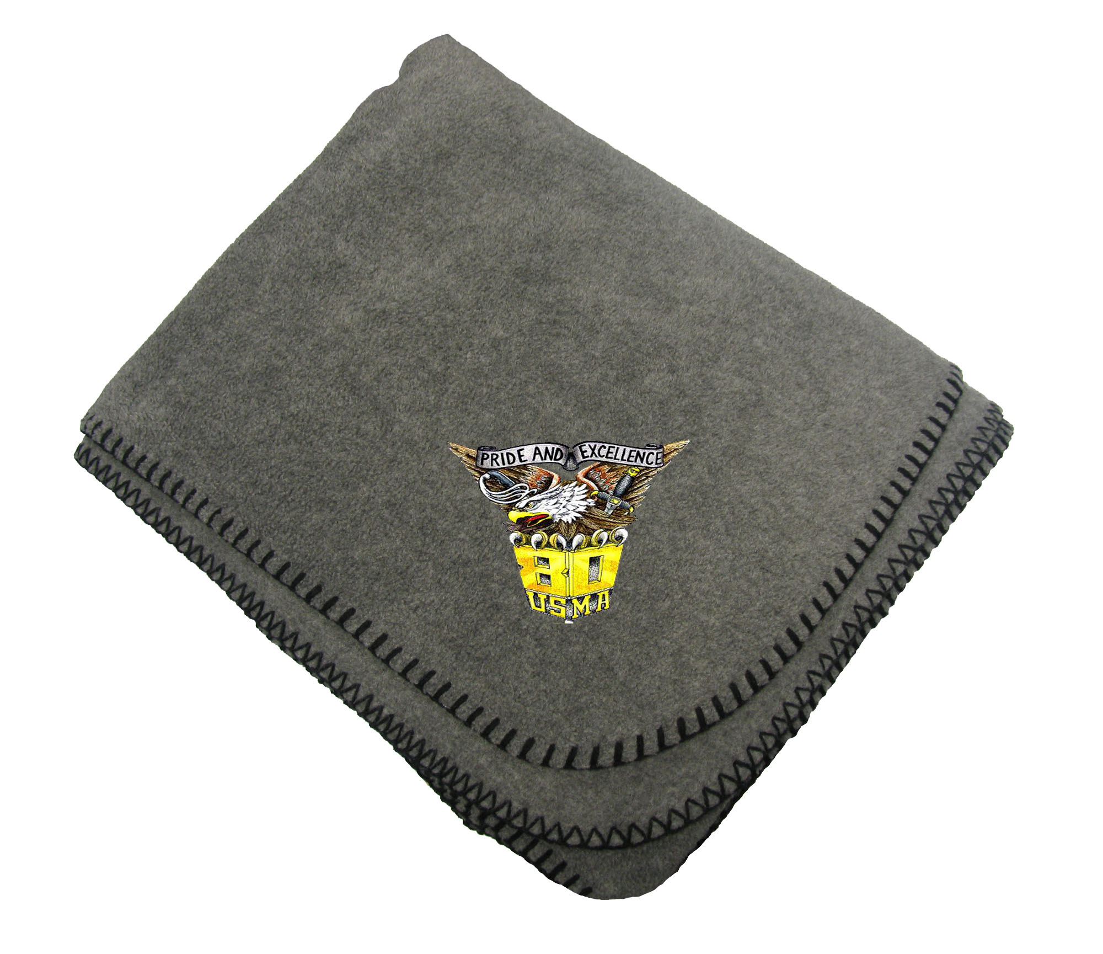  Fleece Blanket – $21.00  Polyester fleece blanket, 50”x60”, features embroidered class crest in one corner.  Available in Charcoal
Crest Tote – L115 | License Plate Frame - R114 | Tervis Tumbler – R603
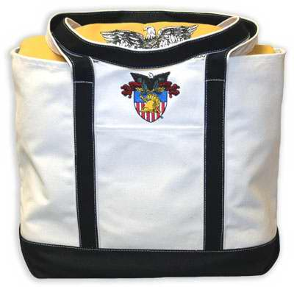  L115 Crest Tote -- $34.00  Super Heavyweight Canvas Tote, 24" x 13" x 5" - 16oz. Designed with a side pocket and decorated with a fully embroidered USMA Crest. | 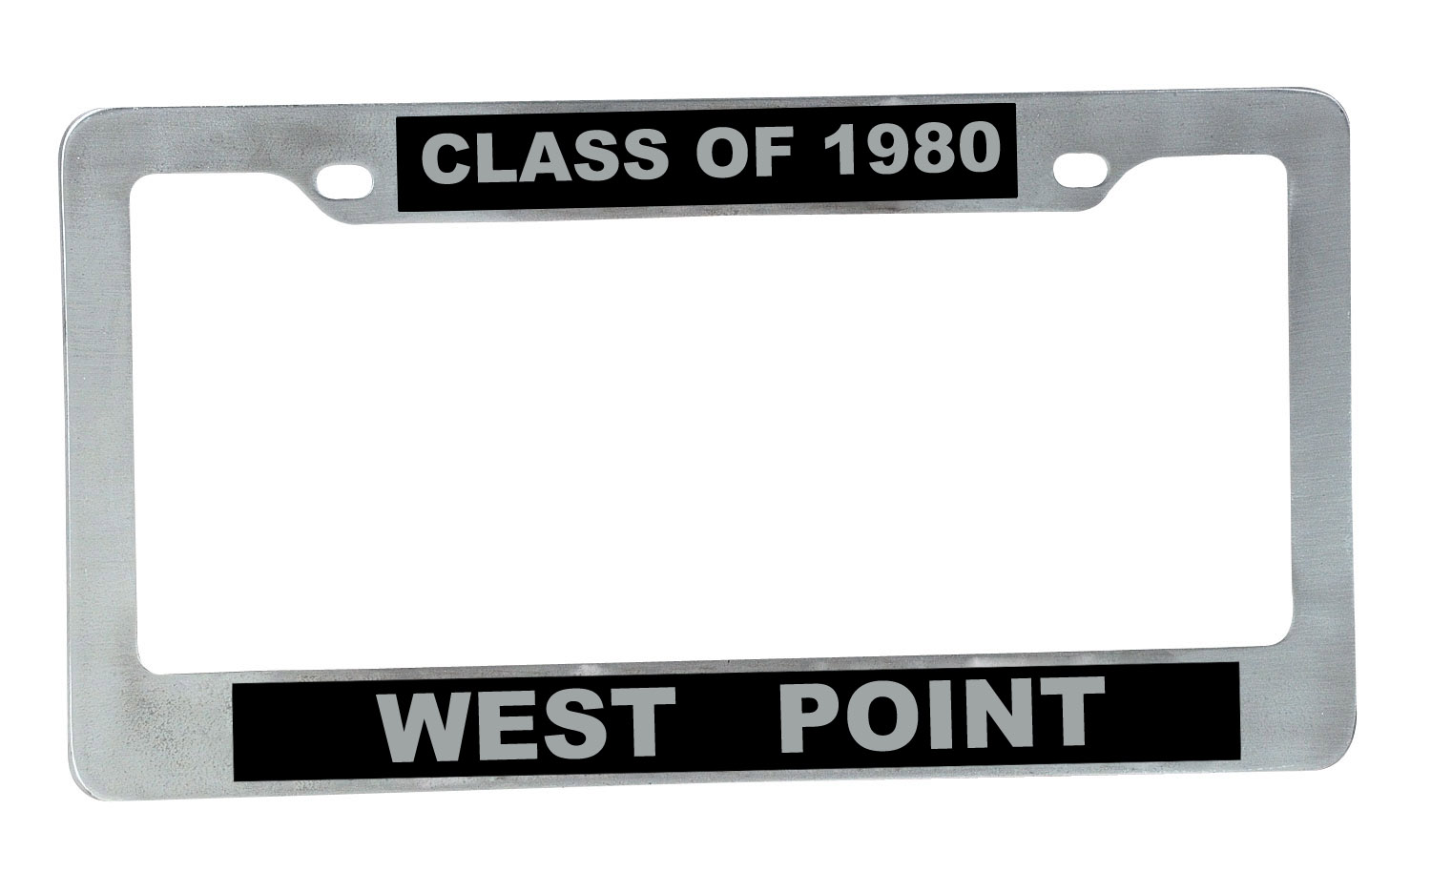  License Plate Frame – $15.00  Chrome license plate frame customized for the Class of 1980. | 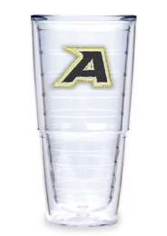  Tervis Tumbler - $16.00  24 oz travel tumbler.  (Lid not included)

Class of 1980 – 30th Reunion Order Form

To pick up merchandise at the reunion, orders must be received NLT 27 AUGUST 2010.
Merchandise will not be available for pick up/shipment prior to registration at HOTEL.

Item # | Quantity | Size | Color  (circle choice) | Description | Price/Unit | Total Amount
R837 |  |  | Black | Men’s CB Polo | $42.00
R401 |  |  | Black | Women’s CB Polo | $42.00
R051 (MEN) |  |  | White | Men’s Crest Polo | $33.00
R051 (WOMEN) |  |  | White | Women’s Crest Polo | $33.00
G496 |  |  | Black or Yellow | Luxe Touch Jacket | $52.00
R101 |  |  | Black | Microfiber Jacket | $57.00
R121 |  | N/A | Charcoal | Fleece Blanket | $21.00
L115 |  | N/A | N/A | Crest Tote | $34.00
R114 |  | N/A | N/A | License Plate Frame | $15.00
R603 |  | N/A | N/A | Tervis Tumbler | $16.00

 |  |  |  | 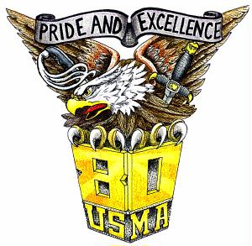 | Subtotal
Shipping Charges: Up to $15, add $9.95; $15.01 -- $30, add $10.95; $30.01 -- $45, add $11.95; $45.01 -- $60, add $12.95; $60.01 -- $75, add $13.95; $75.01 – over, add $14.95; Additional charges will apply to extra heavy orders. |  |  |  |  | NY orders, add 8.125% tax
 |  |  |  |  | Shipping
 |  |  |  |  | Order Total

To Order:
Please make checks payable to: WPAOG Gift Shop

Online: Visit our online webstore at www.westpointgiftstore.com, then click on ‘Reunions’.
Telephone: 800-426-4725 Fax: 845-446-1279 Email: giftshop@wpaog.org

Or, complete this order form and mail to:  Attn: Class of 1980 30th Reunion  WPAOG Gift Shop  698 Mills Road  West Point, NY 10996 | __________ YES, I will be attending the reunion and will pick up my merchandise at the registration table. I do not need to add shipping charges to my order total above.
 | __________ NO, I am unable to attend my reunion or pick up my order. Please ship to my address. I have added shipping charges to my order total above.

Name:
Address:
City/State/Zip
Phone Number (Daytime): | E-Mail:
Credit Card Number: | Expiration Date:
Signature: Discover | Visa MasterCard AMEX

Thank you for your order!

