2D MINI-REUNION CLASS CRUISE
WHO: All members of the "None will Surpass" '67 Class, family and friends
WHAT: 10 Night Panama Canal Cruise aboard the 62,000 gross ton Holland America Flag Ship Rotterdam VI
WHEN: Friday, 12 November 2004 through Monday, 22 November 2004
WHERE: Fort Lauderdale, FL - Half Moon Cay, Bahamas—at sea—Willemstad, Curacao—Oranjestad, Aruba
—at sea—Cruise Tour of Panama Canal/Gatun Lake—Puerto, Costa Rica—at sea—at sea—
Fort Lauderdale, FL
PRICE: The below table indicates prices per person (P/P) and the cabin categories we have available to our
group.
In limited supply are:
QUADS, cabins that will accommodate 3 or 4 people.
Cabins with balconies.
If you are considering either of these types of cabins contact me ASAP.
Prices are for the cruise only and do not include air. Prices do not include drinks, tours, gambling expenses, or on-board purchases. However, as with Alaska, I will be checking with independent tour operators to see if we might be able to get private tours on an "as desired" basis. More information on this will follow.
Category | Block | HAL Phone Quotes (3/12/04)  Inc. Port Tax | Our Price  (Inc. Port Tax) |  | Savings
S Deluxe Veranda Suite | 2 | $4,304.32 | $3,635.18 |  | $669.14
A Veranda Suite | 10 | $2,735.26 ⁽¹⁾ | $2,444.99 |  | $290.27
B Veranda Suite | 5 | $2,634.99 ⁽¹⁾ | $2,357.01 |  | $277.98
C Large Ocean View | 10 | $2,054.35 | $1,767.91 |  | $286.44
D Large Ocean View | 10 | $2,024.35 | $1,743.50 |  | $280.85
 |  |  | Before ⁽²⁾ 4/30/04 | After ⁽²⁾  4/30/04
DD Large Ocean View | 5 | $1,647.99 | $1,647.99 | $1,719.54 | -0-
E Large Ocean View | 10 | $1,625.41 | $1,625.41 | $1,695.59 | -0-
F Large Ocean View | 7 | $1,579.74 | $1,579.74 | $1,663.81 | -0-
G Large Ocean View | 5 | $1,508.86 | $1,508.86 | $1,607.62 | -0-
I Large Inside | 3 | $1,647.99 ⁽¹⁾ | $1,491.09 |  | $156.09
K Large Inside | 5 | $1,579.74 | $1,431.21 |  | $148.53
L Large Inside | 5 | $1,556.64 | $1,410.94 |  | $145.70
⁽¹⁾ Closed – Sold Out—Can not be booked outside the group
⁽²⁾ Holland America presently has a 6 cabin upgrade promotion in effect. Through 4/30/04 the promotional rates will be applicable for our group. Thereafter, the rate will be adjusted as indicated above.
3rd/4th person in cabin $750 + $373.21 port/tax P/P
Deposit of $500 P/P to hold cabin ASAP. Final payment due 29 August 2004.

MISCELLANEOUS:
- We will have a private cocktail party (your friends and guests included in our group are naturally invited);
- Dining as a group (I've requested late dining);
- Plus a few other extras. More information to follow.
CRUISE INFORMATION:
I have requested a color brochure from HAL and, upon receipt, will get it out by mail. A possible option will be via email attachment (but not everyone will be reached that way.)
BOOKING DETAILS:
I purchased a cabin with veranda for the Alaskan cruise, but, as cool as it was, I felt I did not get my money's worth. A longer cruise to the deep Caribbean, on the other hand might be worth considering ? Margaret and I took an 11 day cruise from NY to Aruba and back to San Juan. Every morning, with the exception of the, we had breakfast delivered to our cabin and ate it on the balcony. (Life's tough!). Remember, though, those cabins are first come, first served, and I do not have many of them. If all that we have been allocated get booked, the best I can offer is to put you on a waiting list in hopes some other agency fails to sell out all they've reserved.
INSURANCE:
This is a personal thing. If you have a pre-existing medical condition, have issues at home (sick family member), or just for peace of mind, consider getting insurance. It will save money if you have to cancel
after final payment or require med-evac from the Caribbean (that could run up to $10,000!) I can provide you with more details as desired.

QUESTIONS:

- Email me: everettelucas@comcast.net or Home: (732) 542-1641, Work: (732) 380-3665
- Or contact any of our class cruise committee:
Hap Trainor: CWTESQ@aol.com or Home: (610) 265-8131
Randy Pais: RPAIS@aol.com or Home: (281) 363-2312
Dick Waterman: Rwaterman@caci.com or Home: (703) 481-1314

CRUISE REGISTRATION FORM

Please fill out one of these forms for each cabin you book.

Occupant #1: DOB:
(As Name appears on Passport or Other Photo ID)

Occupant #2: DOB:
(As Name appears on Passport or Other Photo ID)

Occupant #3: DOB:
(As Name appears on Passport or Other Photo ID)

Occupant #4: DOB:
(As Name appears on Passport or Other Photo ID)

Mailing Address:

Email address:
Home Phone: Work Phone:

Special Requirements:
(Dietary, Handicap)
Cabin Category:
Insurance (Circle): No Yes

Payment Type (Circle): Cash/Check Credit Card

For Credit Card Payments:
Name as on Card:

Card Type:

Credit Card Number:

Expiration:

Looking forward to seeing you all again!!!

MAIL THIS FORM & DEPOSIT/PAYMENT TO:

Everett Lucas
6 Violante Court

Eatontown, NJ 07724

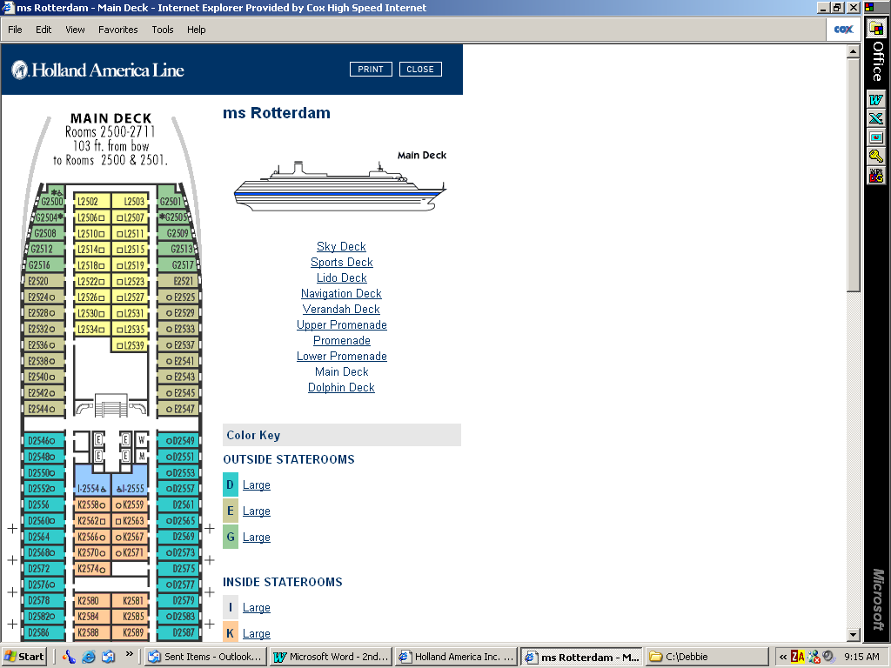
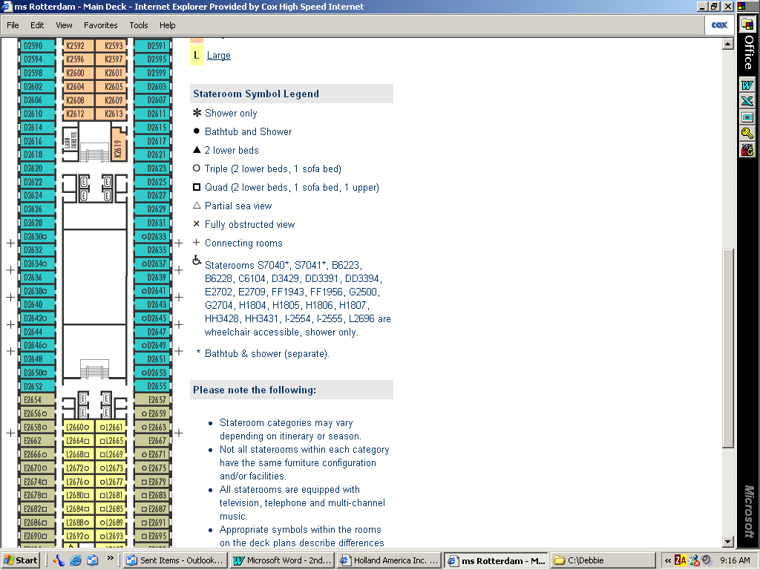
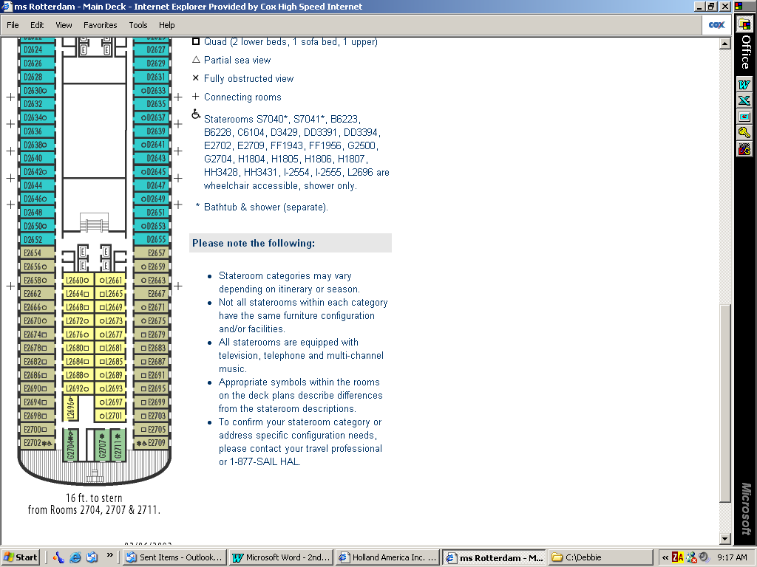
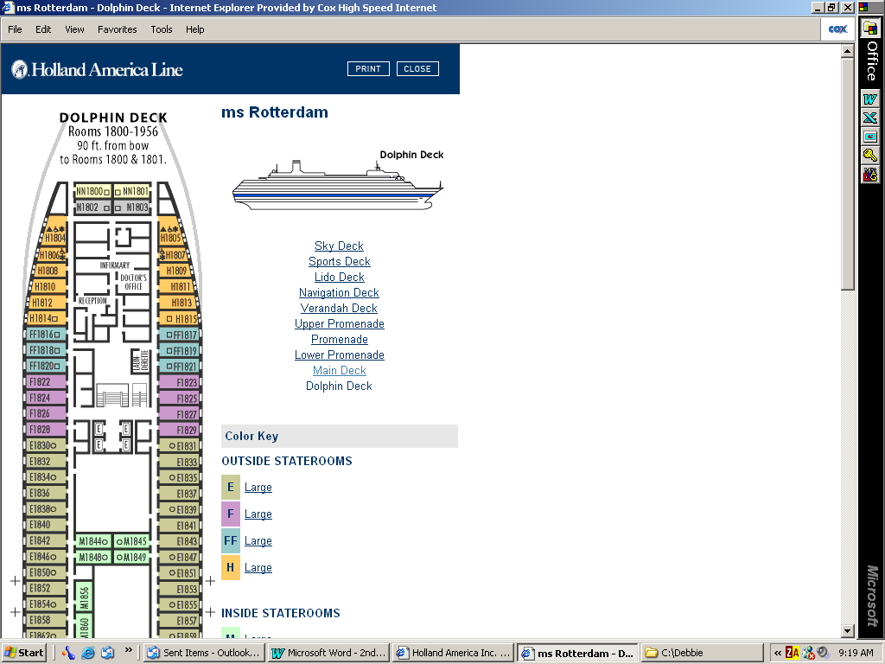
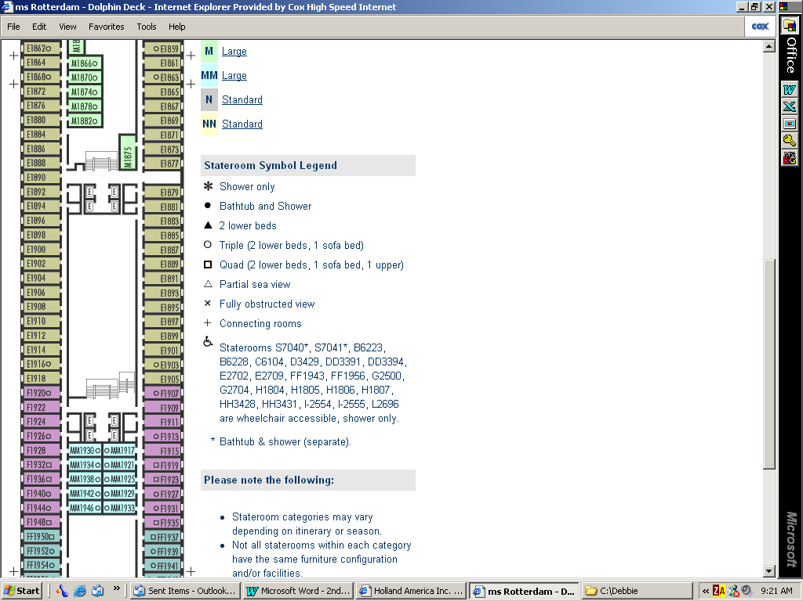
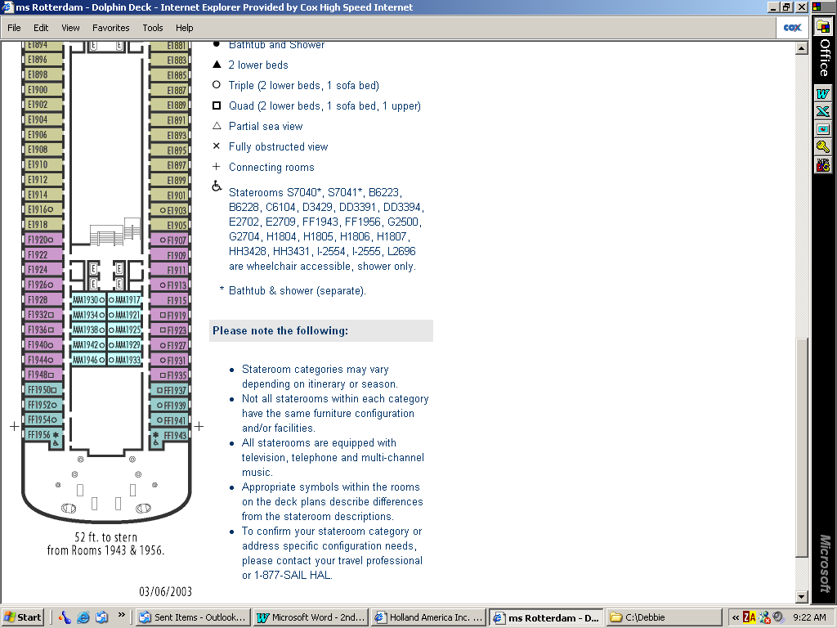
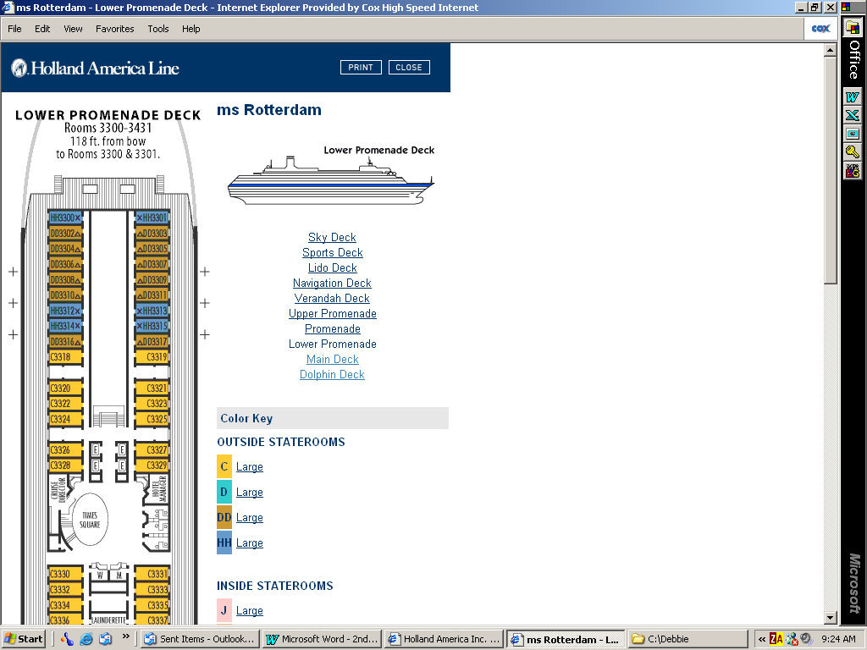
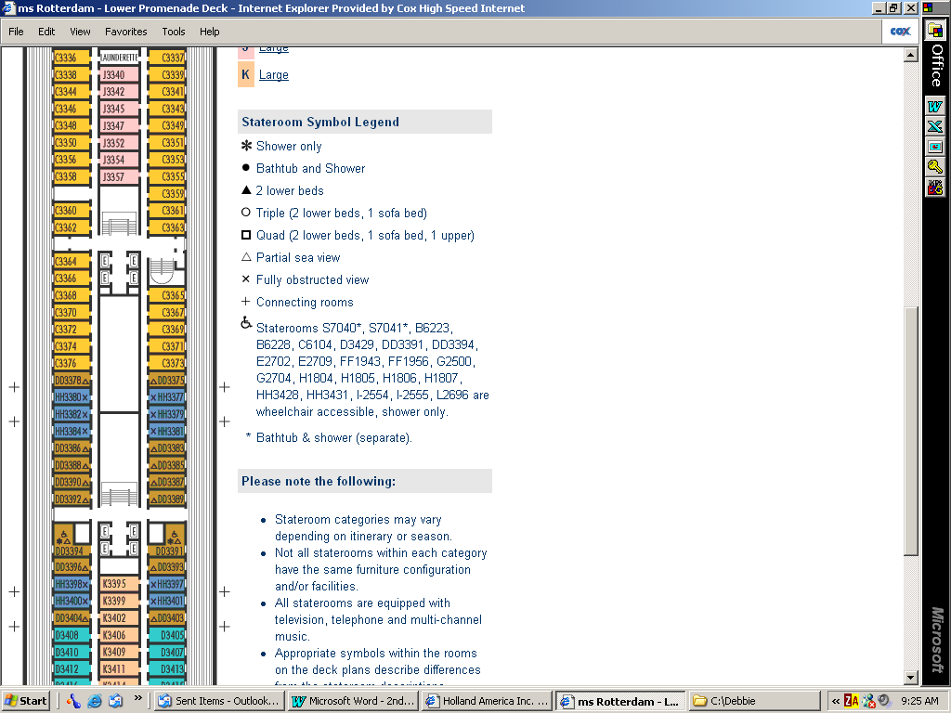
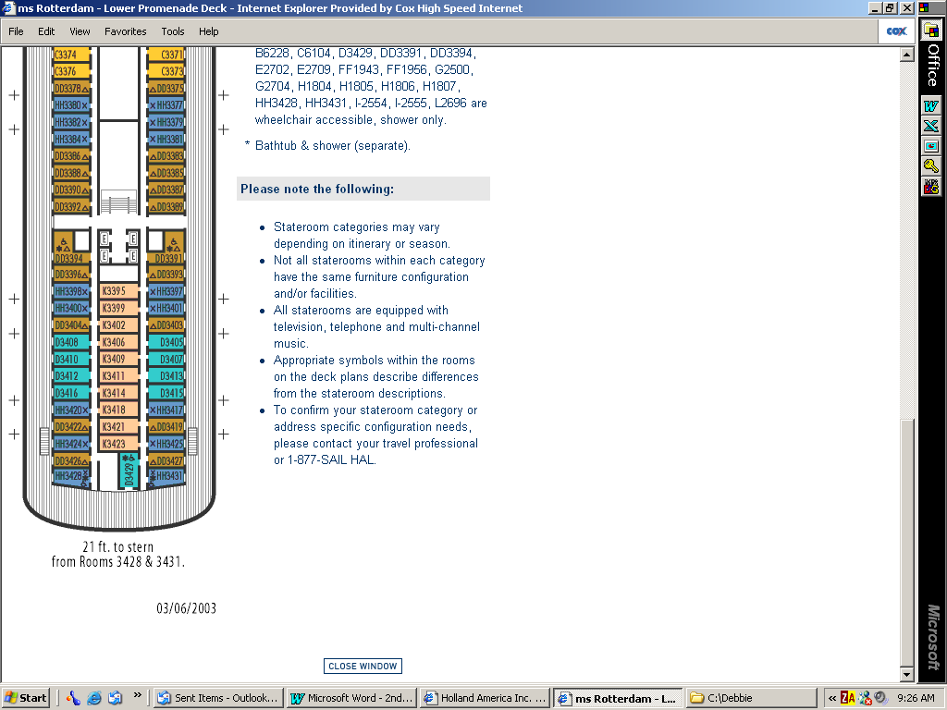
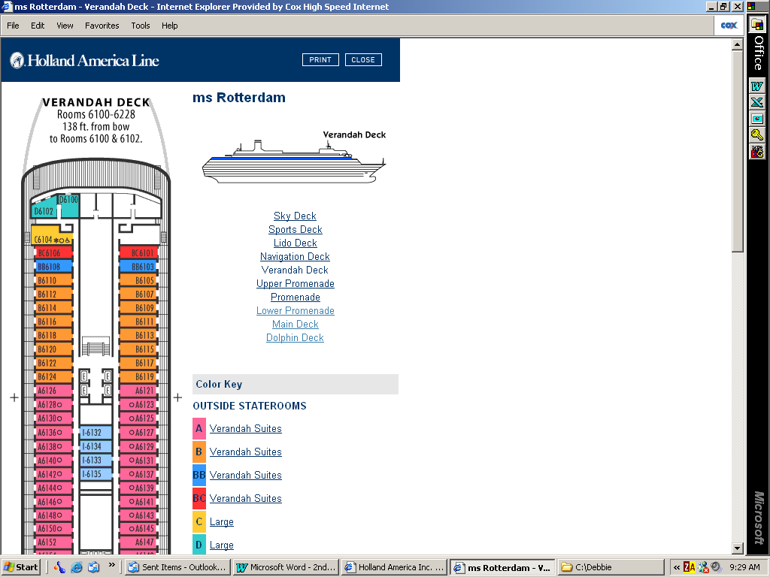
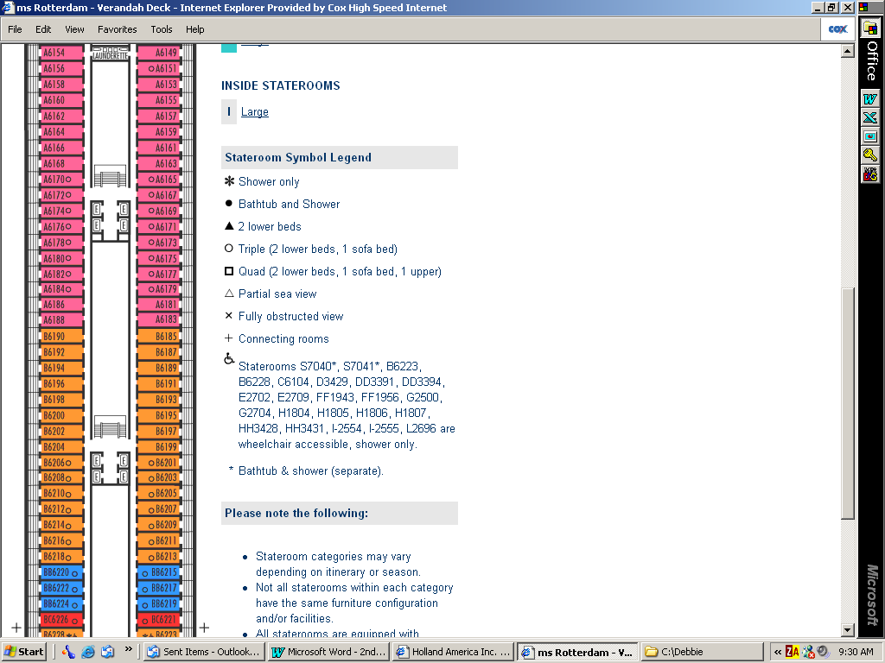
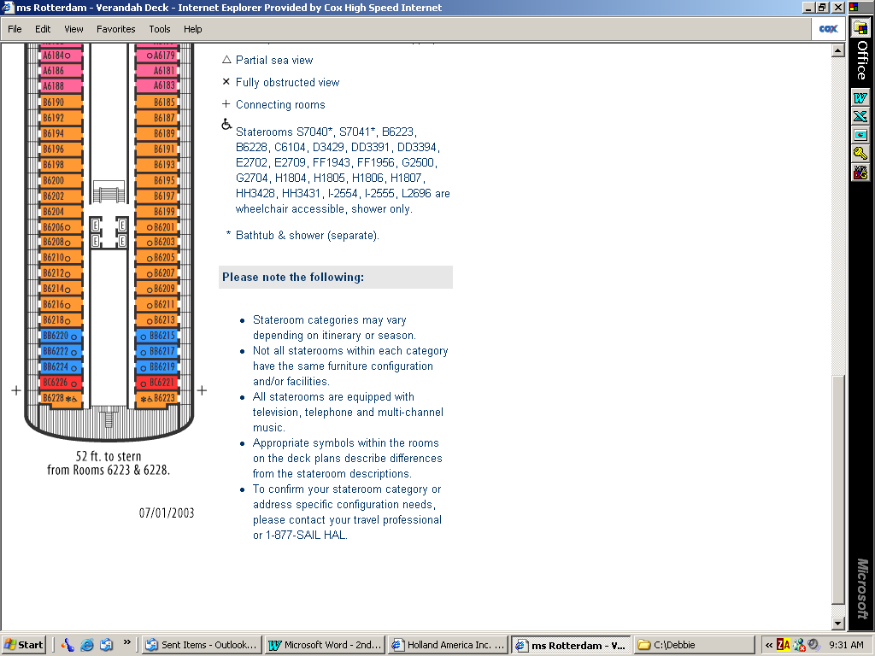
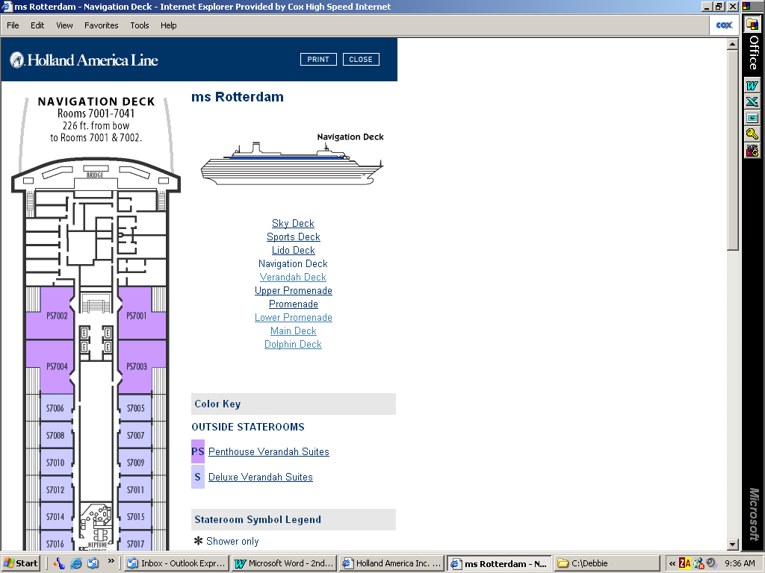
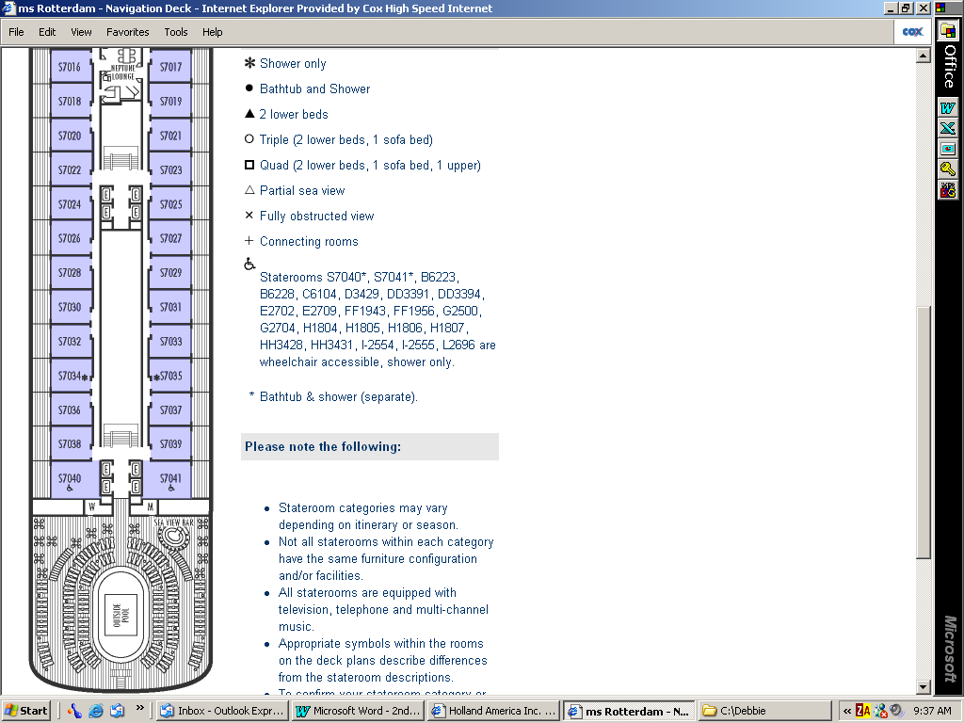
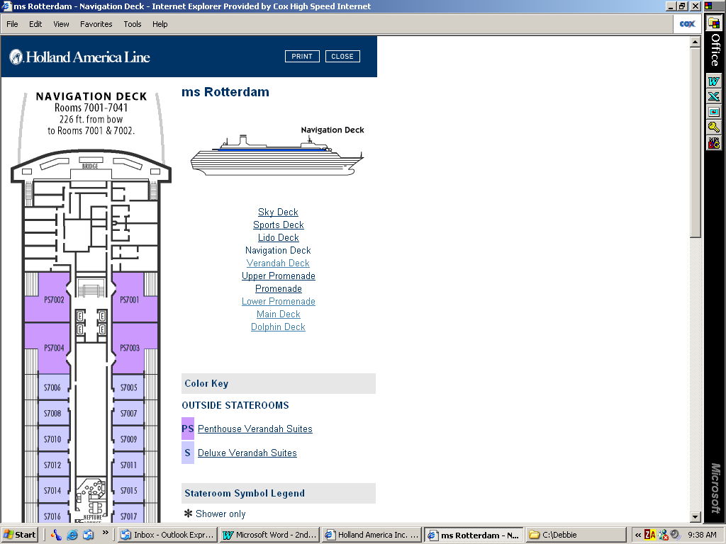
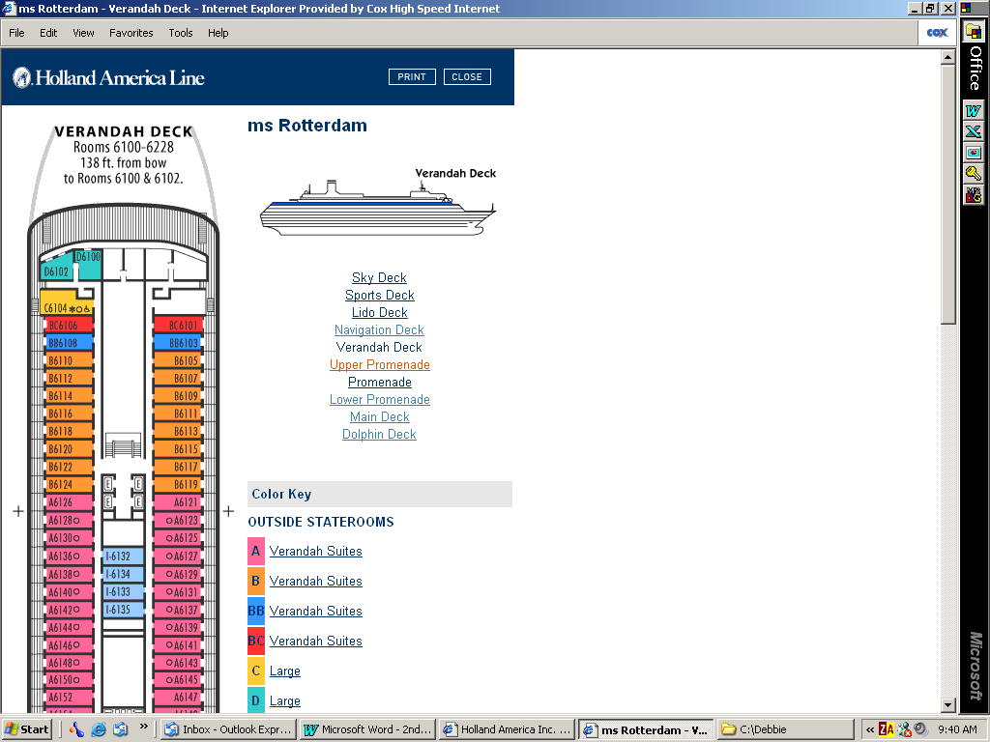
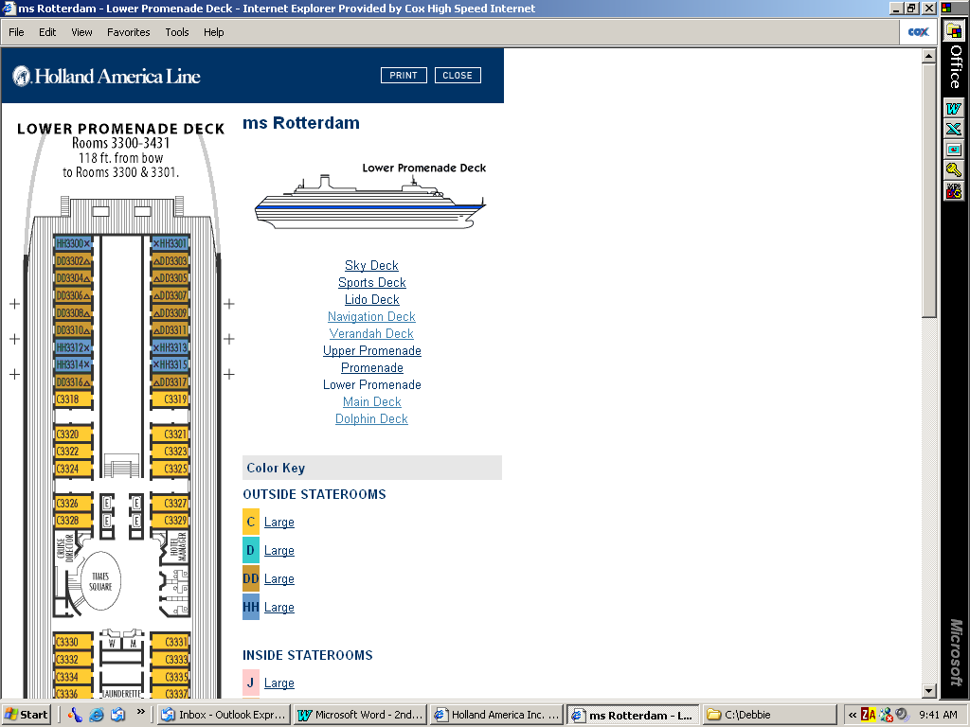
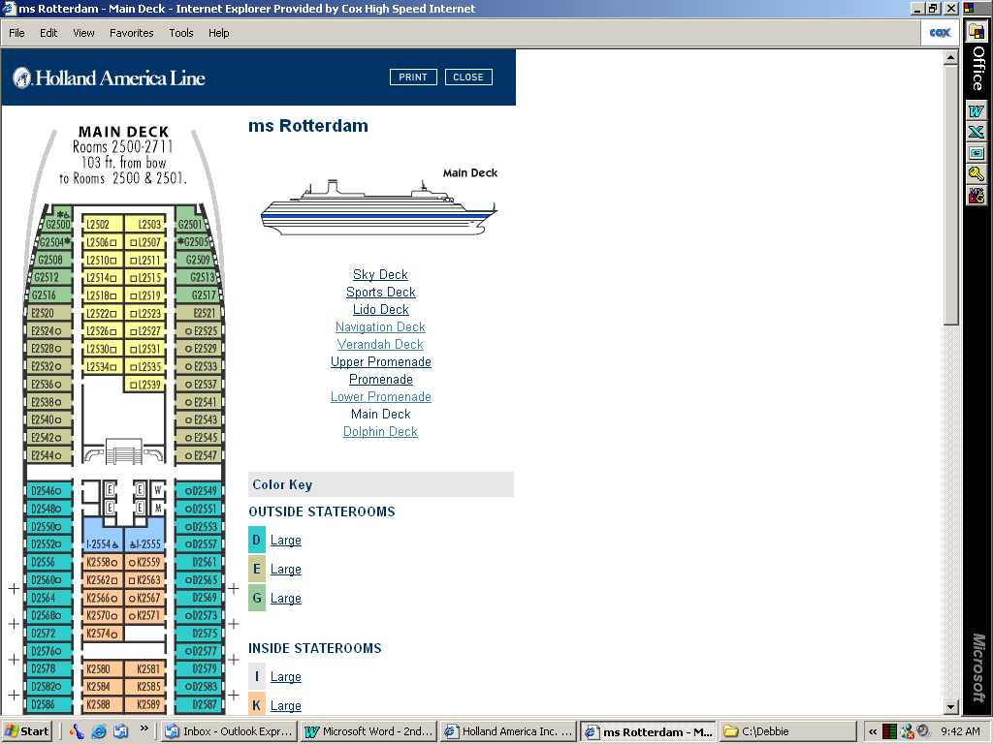
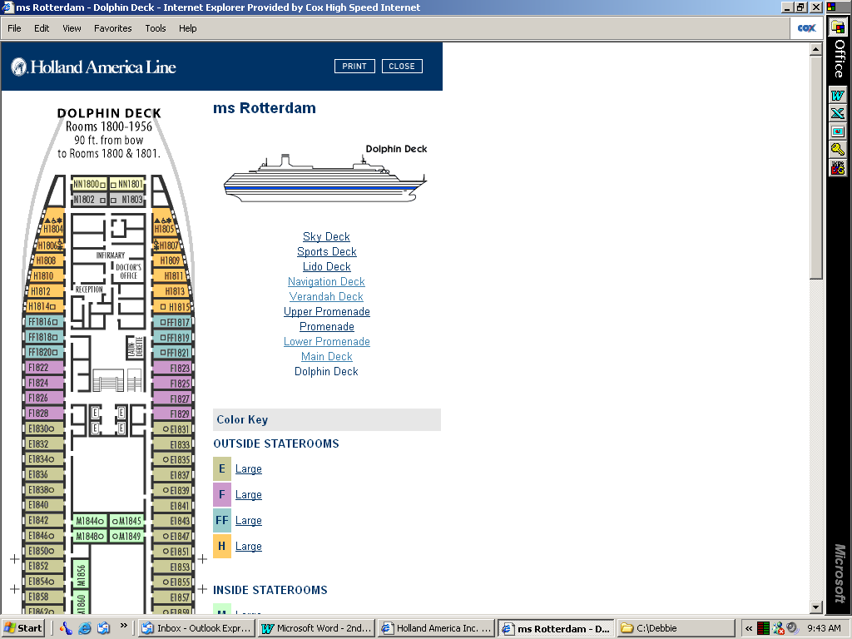
View the ship’s deck plans on-line:
http://www.hollandamerica.com/fleet/fleetHome.do?ship=rt
Select: Explore Deck Plans (right hand side of screen)

